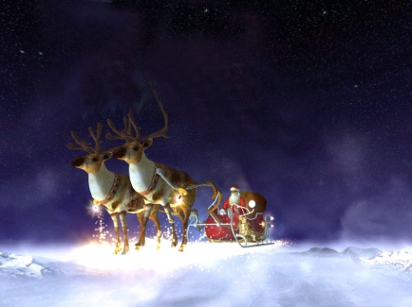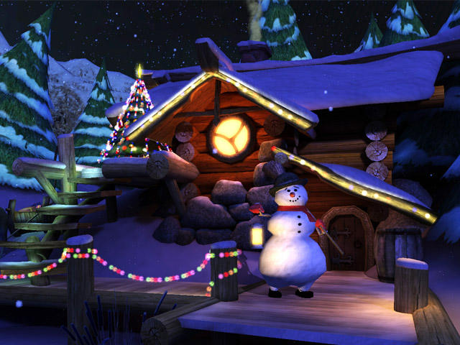

j0187905%5b1%5dj0187905%5b1%5dj0187905%5b1%5dj0187905%5b1%5dj0187905%5b1%5dj0187905%5b1%5dj0187905%5b1%5dj0187905%5b1%5d

MCj04361720000[1]MCj04361720000[1]MCj04361720000[1]MCj04361720000[1]MCj04361720000[1]MCj04361720000[1]MCj04361720000[1]MCj04361720000[1]MCj04361720000[1]MCj04361720000[1]MCj04361720000[1]MCj04361720000[1]MCj04361720000[1]

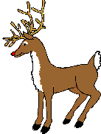

*This certificate comes from the home of Santa and Mrs Claus, all the Elves, and Rudolph and all the reindeer at the North Pole.*

j0187905%5b1%5dSO02915_%5b1%5d

This Christmas Certificate is presented to

MCj04361720000[1]MCj04361720000[1]MCj04361720000[1]MCj04361720000[1]MCj04361720000[1]MCj04361720000[1]MCj04361720000[1]Type child’s name in here (or delete this text and handwrite their name in).

Wow, what a year you have had this year. I have heard all about you (from your teacher) and what a well behaved, polite and kind young person you are. As you know, we are all very busy here at the moment with it being Christmas time, but I just wanted to drop you a quick note to let you know we are all thinking about you up here at the North Pole.

j0285794%5b1%5d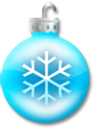MCj04391700000[1]MCj04391700000[1]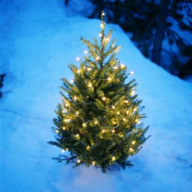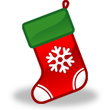MCj04391700000[1]Have a very Safe and Happy Christmas and New Year. A very big Merry Christmas to you and your family.

MCj04391700000[1]

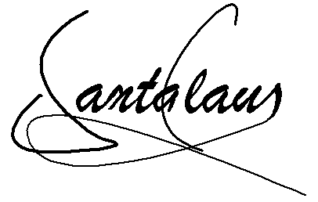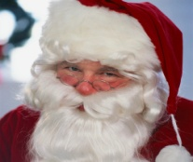



C:\Users\Chris\Pictures\pinebow.gifC:\Users\Chris\Pictures\pinebow.gifTeacher: My special signature: