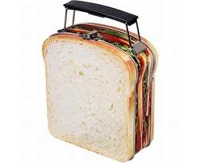
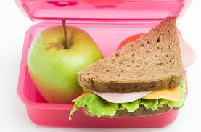
To the teacher: Please fill out this form based on your class and return it before the end of playtime on the actual day.
Date: Day: School:
Your Room Number/Name: Teachers Name:
Class Years/Levels (circle): Year 0 Year 1 Year 2 Year 3 Year 4 Year 5 Year 6 Year 7 Year 8
Number of lunches to be supplied to your room: (the number of children in your class on the actual day). If you have any latecomers who arrive to class AFTER this form has left you, please send a runner to let us know asap. If you have any spare, or are short of any, just let me know.
Children: Classroom Staff:
Allergies: The footer of this page shows what is being given for lunch. Please note that some of these ingredients may contain traces of nuts/dairy etc such as in the mayanaise and biscuits. If you have a child that is allergic to any ingredients, please ensure they do not get a lunch unless it has been specifically made for them. If this is the case, please let me know PRIOR to us starting the lunches (we usually start at the end of playtime), as we will make a roll without certain ingredients. You can make any notes on the bottom of this slip (which I read before the kids and I start making the lunches). If I am unsure, I will either come and see you or someone at the school office.
NB: This option is ONLY for any child who has a known allergy to the school-it is NOT for children who simply just don’t like a particular ingredient or are fussy eaters (they can pick out what they don’t want).
The lunches will be delievered to your room close to lunchtime. The children who will deliever them will simply drop them off to you. It is up to you to hand them out to the children/staff in your class. It is done this way so we do not interupt you if you are still teaching, and also because I need the children delievering them, back with me asap for cleanup duties.
Please do not send your class to me for collection of the lunches.
Extra notes from the teacher to me (if any).
Also list below if you have any children in your class with any food allergies that are known to you (please list the childs name and what they are allergic to/what they cannot have from the ingredients listed below in the footer).
Today’s Menu:

Teachers Name: Teachers Signature:

