Board Work 10 (DD)
Maths 1. 8+20= 2. 15-10-1= 3. 2 x 3 = 4. 3 x 2 = 5. 2x10= 6. 10x2=

Handwriting

4
3
5

T (go to the end of the line) Plus 3 words for each letter.

t (go to the end of the line)

Sl (go to the end of the line) Plus 2 words for the blend
Make sure you do a 2 or 3 line border after handwriting.

Word Squares: Write in 3 words or draw 3 pictures for each thing written in the box.
Jobs | Octopus
Rain | Lawns

Syllables and A.O.
Break these into syllables. Then put these into
alphabetical order (A.O).
science, coke, mentos, children
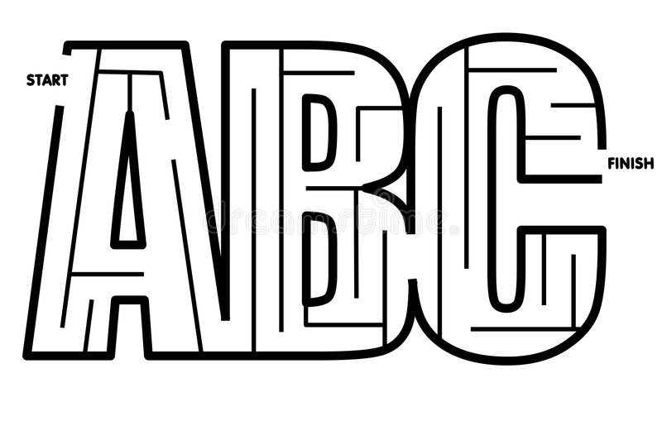
Which one is the odd one out, and why?
Fix Me Up.
1. Tha car wEnt fast; (3 mistakes).
2. our teacher waz laTe again{ (4 mistakes).
Write a sentence.
1. Dontae 2. Dayiss
Opposites.
1. Sleep 2. Frown 3. High
Picture Cues.
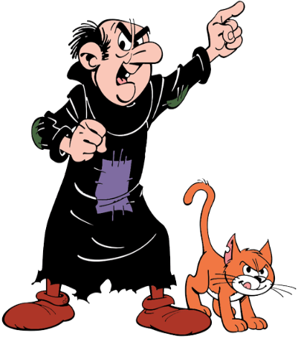
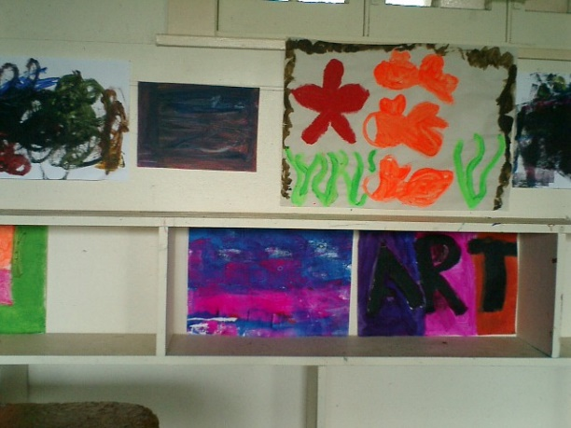
Write 2 sentences and 5 words for the pictures.

