Board Work 11 (DD)
Maths 1. 10+10 = 2. 20-10= 3. 2 x 4 = 4. 4 x 2 = 5. 3x2= 6. 2x3=
-2
+2
7. 3 people had $2 each. Total= 8. 1/2 of 10=

3
2
4

2
3
4

Handwriting
Uu Plus 3 words for the letter.

Sh Plus 2 words for the beginning blend.

ed Plus 2 words for the end blend.
Tuesday and Thursday: Do a border after handwriting.

Word Squares: Write in 2 words or draw 2 pictures for each thing written in the box.
Cross Country | Snails | Gymnastics

Alphabetical order. a, b, c, d, e, f, g, h, i, j, k, l, m, n, o, p, q, r, s, t, u, v, w, x, y, z
door, key, wood, open, shut

Vowels (a, e, i, o, u). Circle the vowels in each word. Write 3 more.
Cat , Bat, Mat, Sat, Hat, _______, _______, _______
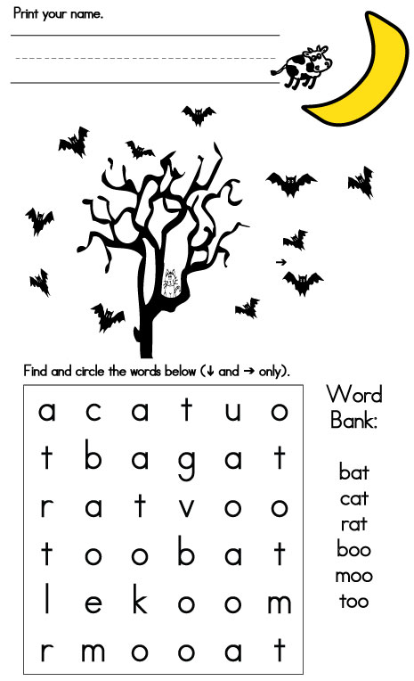
Fix Me Up.
1. tHe door waz open (4 mistakes).
2. ThE cate saT on the mat with A hat! (5 mistakes).

Write a sentence.
1. bird 2. book

Opposites and Similes.
Opposite | Word | Simile
 | Warm
 | Run
Picture Cues.
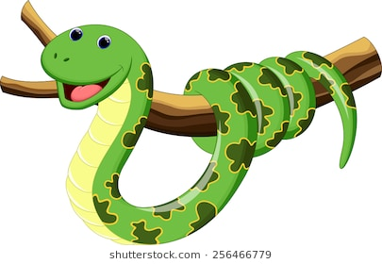
Write 2 sentences or 8 words for the picture.

