Board Work 12 (DD)
Maths 1. 20+10 = 2. 30-10= 3. 2 x 5 = 4. 5 x 2 = 5. 3x3= 6. 3x3=
-3
+3
7. 4 people had $2 each. Total= 8. 1/2 of 8=

5
4
6

3
4
5

Handwriting
Vv Plus 3 words for the letter.

Th Plus 2 words for the beginning blend.

ing Plus 2 words for the ending.
Tuesday and Thursday: Do a border after handwriting.

Word Squares: Write in 2 words or draw 2 pictures for each thing written in the box.
Tractor | Flies | Grass

Alphabetical order. a, b, c, d, e, f, g, h, i, j, k, l, m, n, o, p, q, r, s, t, u, v, w, x, y, z
pillow, blanket, warm, sleep, room

Vowels & List 1 Words (a, e, i, o, u). Circle the vowels in each word.
a, I, it, to Now write one more word you know how to spell.
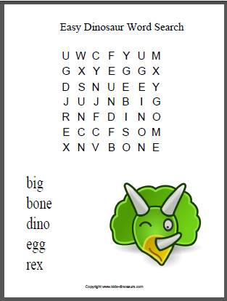
Fix Me Up.
1. the birD flew in ot the tree.. (4 mistakes).
2. dayiss and DoNtae both start with aa D? (4 mistakes).

Write a sentence.
1. Truck 2. Snake

Opposites and Similes.
Opposite | Word | Simile
 | Sad
 | Push
Picture Cues.
Write 2 sentences or
8 words for the picture.

