Board Work 13 (DD)
Maths 1. 30+10 = 2. 40-10= 3. 2 x 6 = 4. 6 x 2 = 5. 3x4= 6. 4x3=
-4
+4
7. 5 people had $2 each. Total= 8. 1/2 of 6=
X
2
1
2

4
5
6

Handwriting
Ww Plus 3 words for the letter.

br Plus 2 words for the beginning blend.

y Plus 2 words for the ending letter.
Tuesday and Thursday: Do a border after handwriting.

Word Squares: Write in 2 words or draw 2 pictures for each thing written in the box.
Music | Albatross | Sky

Alphabetical order. a, b, c, d, e, f, g, h, i, j, k, l, m, n, o, p, q, r, s, t, u, v, w, x, y, z
paper, rubber, felts, lines, write

Vowels & List 1 Words (a, e, i, o, u). Circle the vowels in each word.
and, in, my, was Now write one more word you know how to spell.

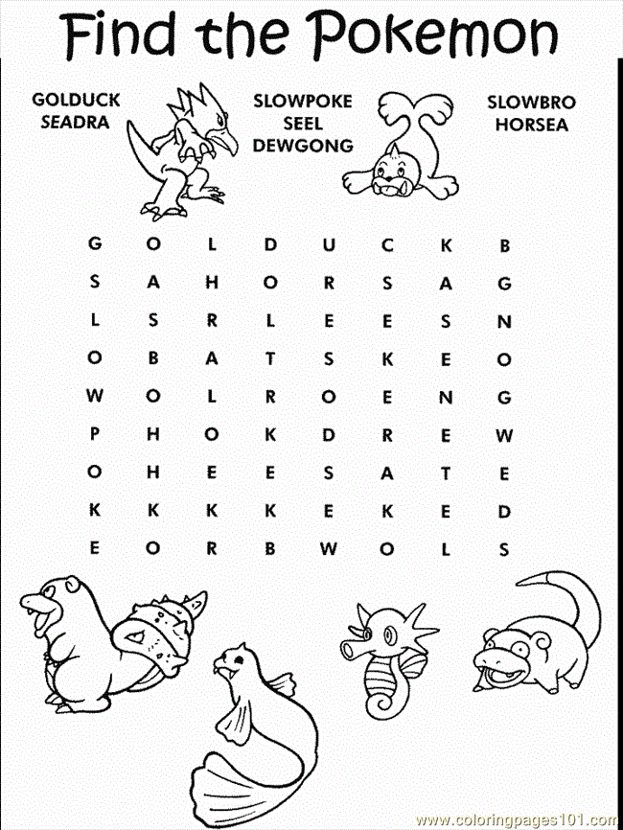
Fix Me Up.
1. wE are in Rooom 5” (5 mistakes).
2. oUr school iss pukeatua School. (4 mistakes).

Write a sentence.
1. Camera 2. Pokering

Opposites and Similes.
Opposite | Word | Simile
 | Freezing
 | Tired
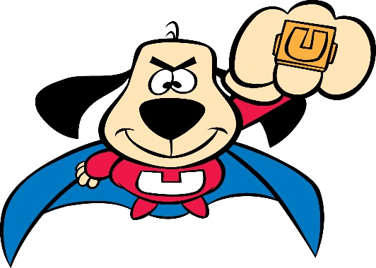
Picture Cues.
Write 2 sentences or
8 words for the picture.

