Board Work 14 (DD)
Maths 1. 40+10 = 2. 50-10= 3. 2 x 7 = 4. 7 x 2 = 5. 3x5= 6. 5x3=
-5
+5
7. 6 people had $2 each. Total= 8. 1/2 of 12=
X
3
2
2

5
6
7

Handwriting
Xx or Yy Plus 3 words for any of the letters.

ch Plus 2 words for the beginning blend.

s Plus 2 words for the ending letter.
Tuesday and Thursday: Do a border after handwriting.

Word Squares: Write in 2 words or draw 2 pictures for each thing written in the box.
Playstation | Caterpillar | Cities

Alphabetical order. a, b, c, d, e, f, g, h, i, j, k, l, m, n, o, p, q, r, s, t, u, v, w, x, y, z
shops, cars, roads, buildings, lights

Vowels & List 2 Words (a, e, i, o, u). Circle the vowels in each word.
at, but, for, got Now write one more word you know how to spell.

Fix Me Up.
1. 2day is ThursDay! (3 or 4 mistakes).
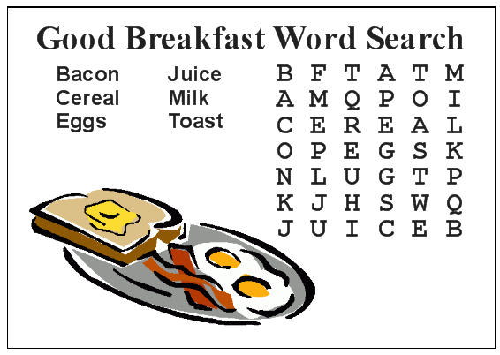
2. saturday is in thee weEkend? (4 mistakes).

Write a sentence.
1. Computer 2. Artroom

Opposites and Similes.
Opposite | Word | Simile
 | Sleep
 | Fast
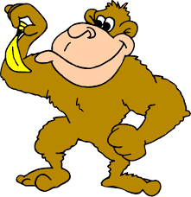
Picture Cues.
Write 2 sentences or
8 words for the picture.

