Board Work 15 (DD) Remember the date (Book).
Maths (after quickfire sheet)
1. If I had $5 and spent $3, how much would I have left?
2. If I had 12 lollies and shared 1/2 with my friend, how many would each of us get?
3. If three of us had 3 pencils each, how many pencils would we have altogether?
4. How many numbers are there on a clock face? 5. How many letters in your 1st name?
Handwriting (Book)
Zz Plus 3 words that start with the letter.

str Plus 2 words that start with the beginning blend.

t Plus 1 word that ends with the ending letter.
Tuesday and Thursday: Do a border after handwriting.

Word Squares: Write in 2 words or draw 2 pictures for each thing written in the box.
Dentist | Baking | Clock

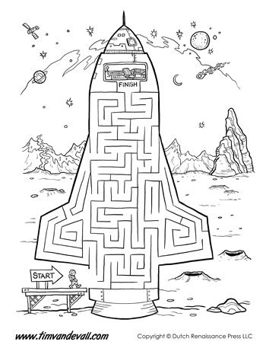
Alphabetical order (Book) a, b, c, d, e, f, g, h, i, j, k, l, m, n, o, p, q, r, s, t, u, v, w, x, y, z
floor, carpet, warm, patterns, lounge
Vowels & List 2 Words (a, e, i, o, u). Circle the vowels in each word.
H a d, h e, i s, m e
Fix Me Up
1. today is MoNday; (3 mistakes).
2. sunday iss in the Weekend* (4 mistakes).
Write a sentence (Book)
1. Had 2. He 3. Is
Opposites and Similes.
Opposite | Word | Simile
 | Zoom
 | High
Picture Cues (Book)
Write 2 sentences or
8 words for one of
the pictures.

Put me in order (Book).
bird, flew, the, in, The, sky.

