Board Work 16 (DD) Remember the date (Book).
Maths (after quickfire sheet)
1. If I had $6 and spent $4, how much would I have left?
2. If I had 14 lollies and shared 1/2 with my friend, how many would each of us get?
3. If four of us had 3 pencils each, how many pencils would we have altogether?
4. How many double numbers are there on a clock ? 5. How many letters in your 2nd name?
Handwriting (Book)
AA Plus 3 words that start with the letter.

dr Plus 2 words that start with the beginning blend.

d Plus 1 word that ends with the ending letter.
Tuesday and Thursday: Do a border after handwriting.

Word Squares: Write in 2 words or draw 2 pictures for each thing written in the box.
Pilot | Water | Alarm

Alphabetical order (Book) a, b, c, d, e, f, g, h, i, j, k, l, m, n, o, p, q, r, s, t, u, v, w, x, y, z
page, book, words, letters, reading
Vowels & List 2 Words (a, e, i, o, u). Circle the vowels in each word.
o f, o n, s h e, s o
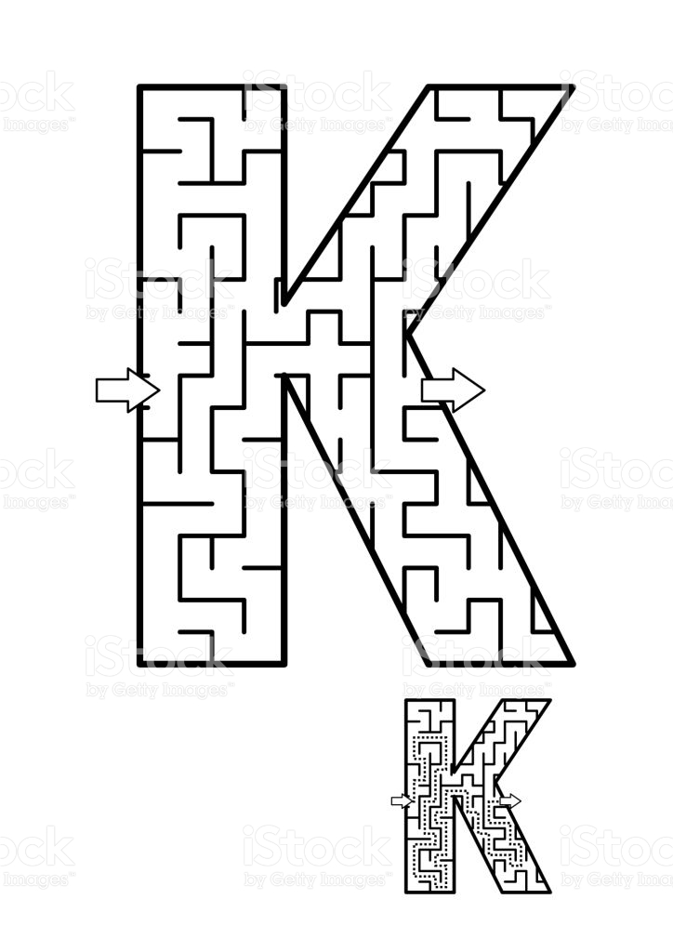
Fix Me Up
1. i aM in Room 4” (3 mistakes).
2. ssiyaD iss my nAme spelt Backwards. (4 mistakes).
Write a sentence (Book)
1. on 2. she 3. so
Opposites and Similes.
Opposite | Word | Simile
 | Left
 | Low
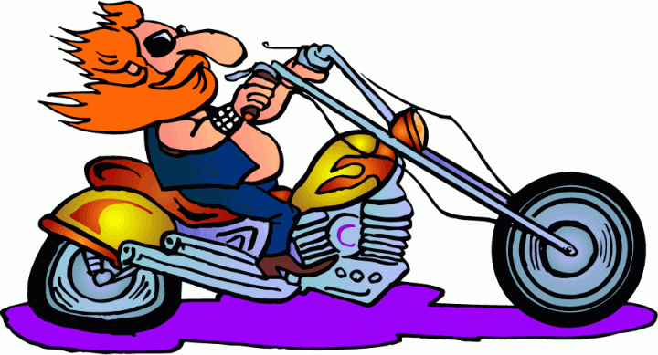
Picture Cues (Book)
Write 2 sentences or
8 words for the picture.

Put me in order (Book).
slowly. crawled, The, snail, very

