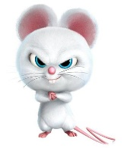
Board Work 18 (DD) Remember the date (Book).
Maths (after quickfire sheet)
1. If I had $7 and spent $3, how much would I have left?
2. If I had 16 lollies and shared 1/2 with my friend, how many would each of us get?
3. If five of us had 2 pencils each, how many pencils would we have altogether?
4. How many single numbers are there on a clock ? 5. How many letters in both of your names?
Handwriting (Book)
CC Plus 3 words that start with the letter.

br Plus 2 words that start with the beginning blend.

p Plus 1 word that ends with the ending letter.
Tuesday and Thursday: Do a border after handwriting.

Word Squares: Write in 2 words or draw 2 pictures for each thing written in the box.
Skiing | 2 or 3 letter words | Baker

Alphabetical order (Book) a, b, c, d, e, f, g, h, i, j, k, l, m, n, o, p, q, r, s, t, u, v, w, x, y, z
liquid, cup, glass, drink, hot
Vowels & List 2 Words (a, e, i, o, u). Circle the vowels in each word.
u p, w e n t, w h e n, y o u
Fix Me Up
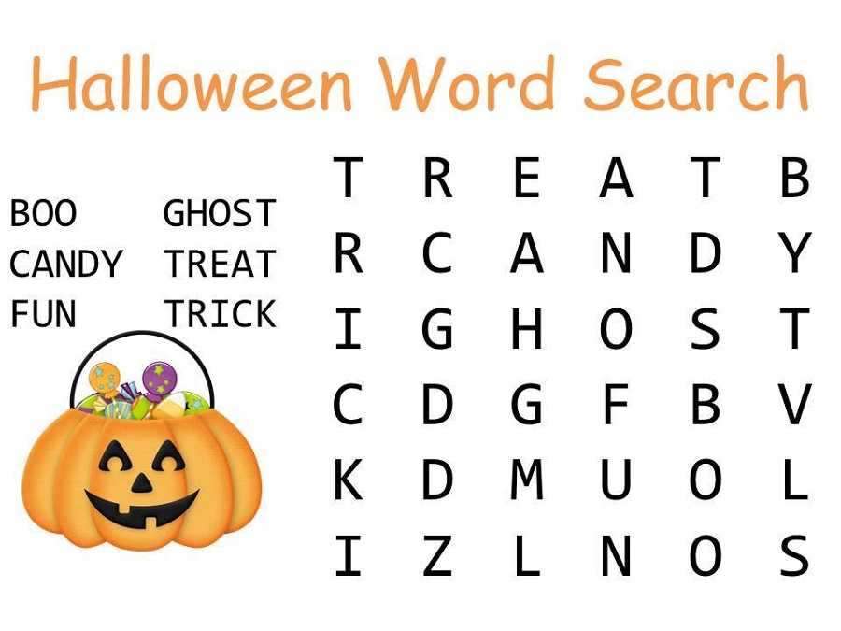
1. A Sentence starts with aa capital? (3 mistakes).
2. a sentence Also ends with a full Stop! (4 mistakes).
Write a sentence (Book)
1. up 2. went 3. you
Opposites and Similes.
Opposite | Word | Simile
 | fall
 | Throw
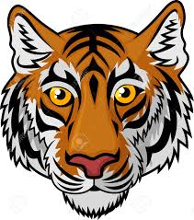
Picture Cues (Book)
Write 2 sentences or
8 words for the picture.

Put me in order (Book).
The, scared, the, tiger, pumpkin.

