Board Work 20 (DD) Remember the date (Book).
Maths (after quickfire sheet)
1. If I had $11 and spent $3, how much would I have left?
2. If I had 20 lollies and shared 1/2 with my friend, how many would each of us get?
3. If 7 of us had 2 pencils each, how many pencils would we have altogether?
4. How many minutes are there on a clock between the 3 and the 6?
Handwriting (Book)
EE Plus 3 words that start with the letter.

ch Plus 2 words that start with the beginning blend.

ly Plus 1 word that ends with the ending letter.
Tuesday and Thursday: Do a border after handwriting.

Word Squares: Write in 2 words or draw 2 pictures for each thing written in the box.
Numbers | Animal names | Place names

Alphabetical order (Book) a, b, c, d, e, f, g, h, i, j, k, l, m, n, o, p, q, r, s, t, u, v, w, x, y, z
Pot, toaster, jug, fork, knife
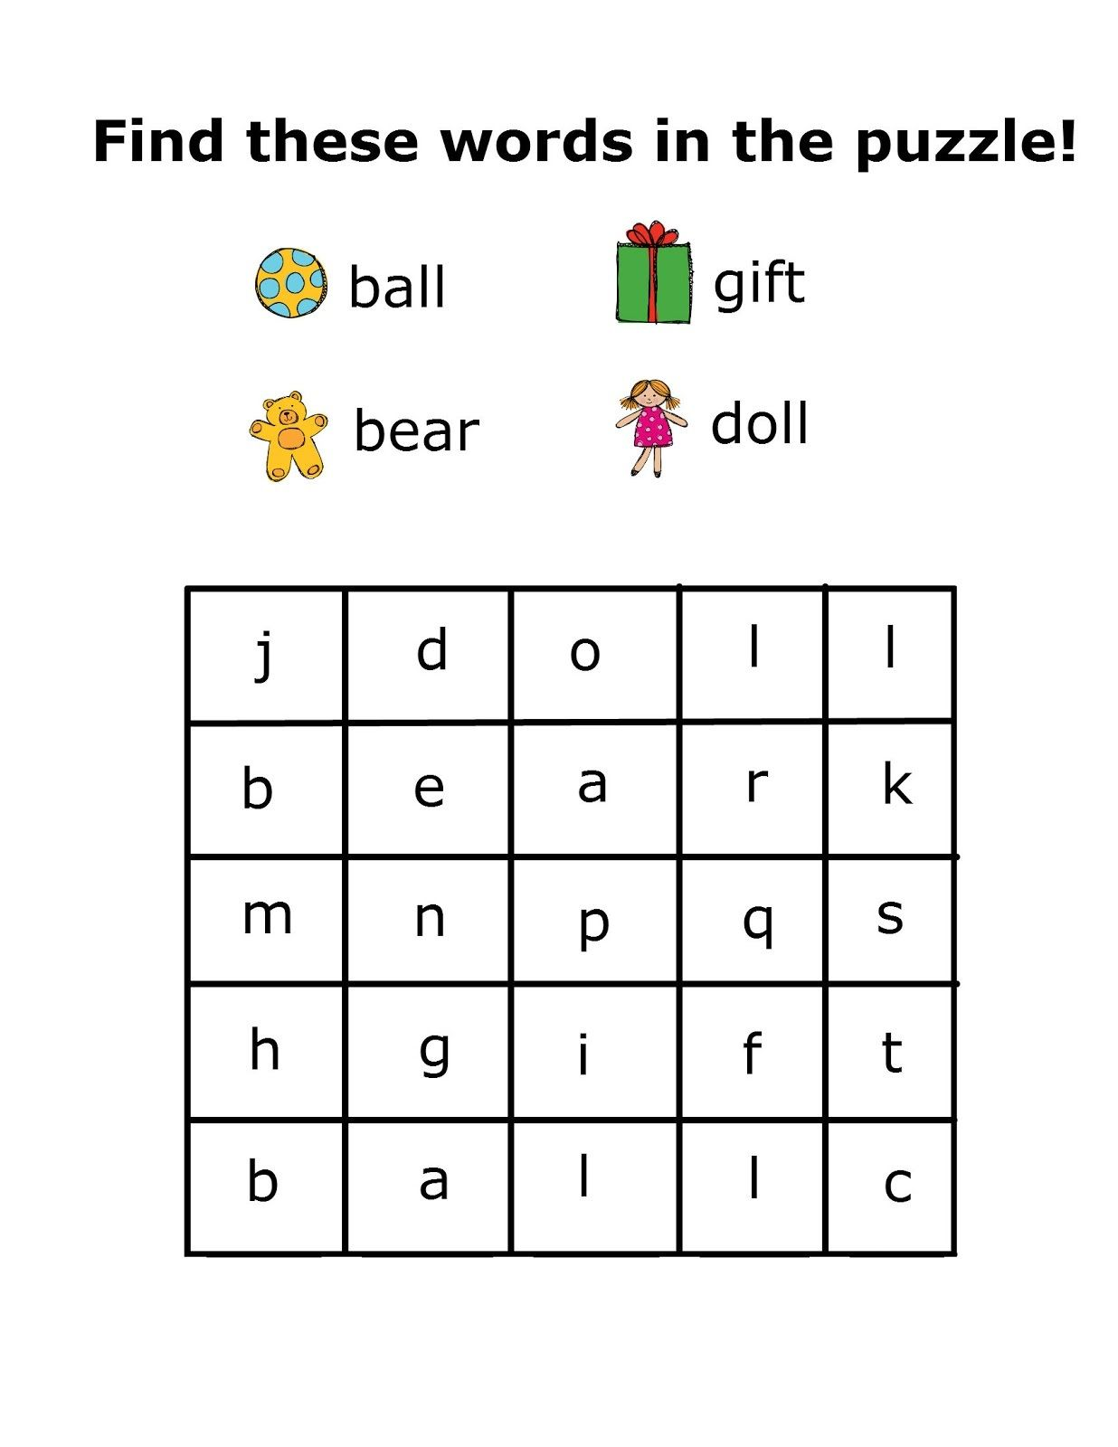
Vowels & List 2 Words (a, e, i, o, u). Circle the vowels in each word.
o f t h a t u p h a d at D a y i s s
Fix Me Up
1. the caT ran after the doG; (4)
2. I don’t know WhaT to wRite? (4)
Write a sentence (Book)
1. was 2. it 3. to
Mixed Up Words (Starts with the Capital Letter).
No. of Vowels | Mixed Word | Correct
 | Wsa
 | Hda
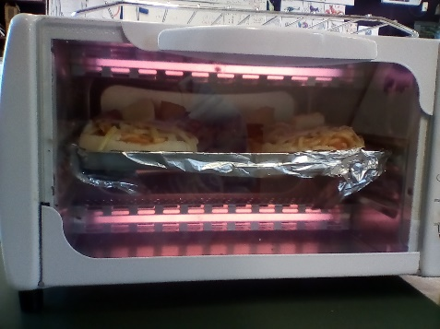
Picture Cues (Book)
Write 2 sentences or
8 words for the picture.

Put me in order (Book).
Last, week, swim. for, a, went, kids,

