Board Work 21 (DD) Remember the date (Book).
Maths (after quickfire sheet)
1. If I had $12 and spent $4, how much would I have left?
2. If I had 18 lollies and shared 1/2 with my friend, how many would each of us get?
3. If 8 of us had 2 pencils each, how many pencils would we have altogether?
4. How many minutes are there on a clock between the 6 and the 9?
Handwriting (Book)
FF Plus 3 words that start with the letter.

sh Plus 2 words that start with the beginning blend.

ed Plus 1 word that ends with the ending letter.
Tuesday and Thursday: Do a border after handwriting.

Word Squares: Write in 2 words or draw 2 pictures for each thing written in the box.
Words | Writing Things | Computer Games

Alphabetical order (Book) a, b, c, d, e, f, g, h, i, j, k, l, m, n, o, p, q, r, s, t, u, v, w, x, y, z
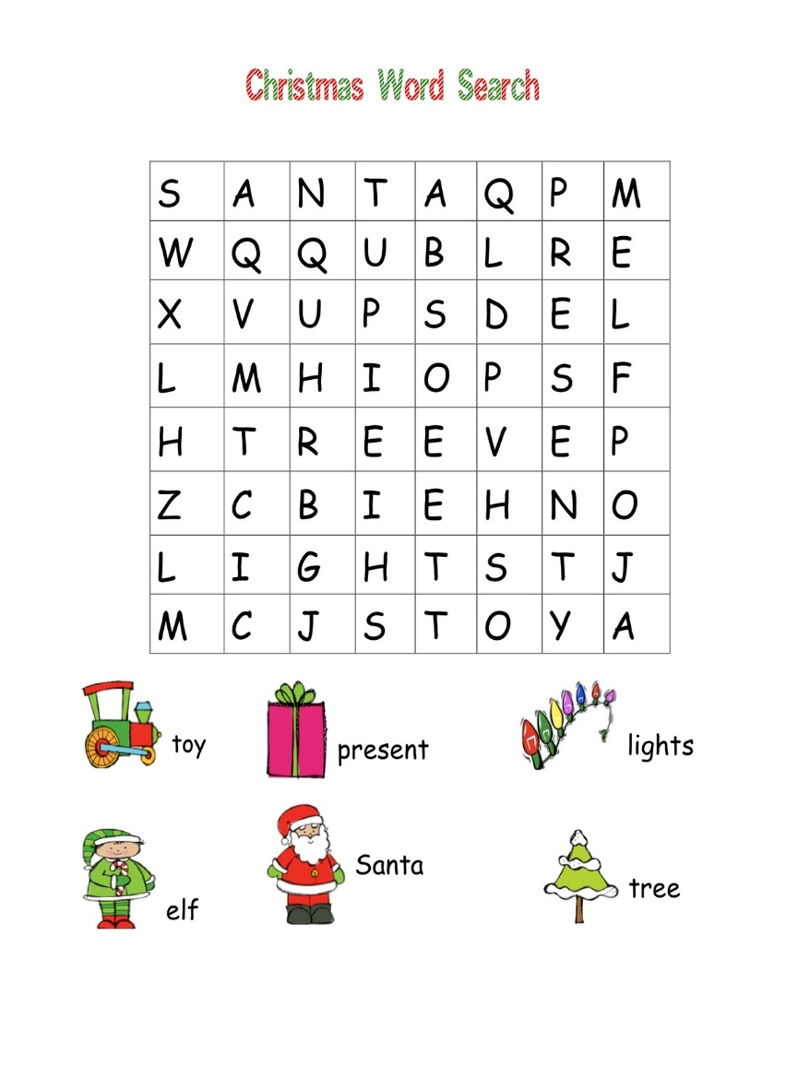
Dontae, Mia, Thomas, Sayan, Kate
Vowels & List 2 Words (a, e, i, o, u). Circle the vowels in each word.
b u t h e o n t h e m w e n t D o n t a e
Fix Me Up
1. We do fitness In The moRning! (4)
2. We R playing soccer iN the morninGs” (5)
Write a sentence (Book)
1. at 2. had 3. of
Mixed Up Words (Starts with the Capital Letter).
No. of Vowels | Mixed Word | Correct
 | oT
 | Adn
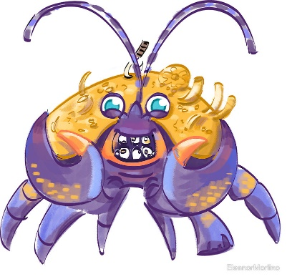
Picture Cues (Book)
Write 2 sentences or
8 words for the picture.

Put me in order (Book).
The, very, slowly. moved, hedgehog,

