Board Work 22 (DD) Remember the date (Book).
Maths (after quickfire sheet)
1. If I had $13 and spent $4, how much would I have left?
2. If I had 16 lollies and shared 1/2 with my friend, how many would each of us get?
3. If 9 of us had 2 pencils each, how many pencils would we have altogether?
4. How many minutes are there on a clock between the 9 and the 12?
Handwriting (Book)
GG Plus 3 words that start with the letter.

tr Plus 2 words that start with the beginning blend.

es Plus 1 word that ends with the ending letter.
Tuesday and Thursday: Do a border after handwriting.

Word Squares: Write in 2 words or draw 2 pictures for each thing written in the box.
Cows | Fences | Paddocks

Alphabetical order (Book) a, b, c, d, e, f, g, h, i, j, k, l, m, n, o, p, q, r, s, t, u, v, w, x, y, z
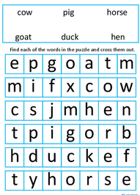
Tommy, Ophelia, Daniel, Jaskaren, Kodee
Vowels & List 2 Words (a, e, i, o, u). Circle the vowels in each word.
f o r i s s h e t h e r e w h e n
Fix Me Up
1. 2day is MonDay? (3)
2. aRe there aNy misTakes here? (4)
Write a sentence (Book)
1. that 2. up 3. but
Mixed Up Words (Starts with the Capital Letter).
No. of Vowels | Mixed Word | Correct
 | nI
 | tI
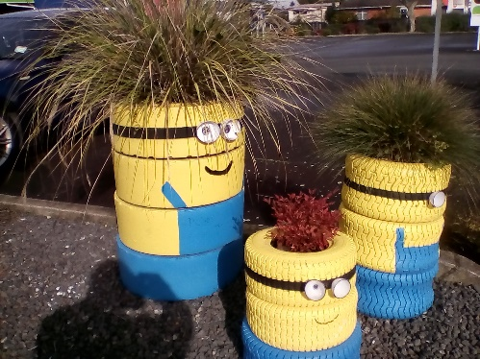
Picture Cues (Book)
Write 2 sentences or
8 words for the picture.

Put me in order (Book).
The, is, 1st , in, the, letter, the, alphabet. ‘a’,

