Board Work 23 (DD) Remember the date (Book).
Maths (after quickfire sheet)
1. If I had $14 and spent $4, how much would I have left?
2. If I had 14 lollies and shared 1/2 with my friend, how many would each of us get?
3. If 10 of us had 2 pencils each, how many pencils would we have altogether?
4. How many minutes are there on a clock between the 12 and the 6 (count in 5’s)?
Handwriting (Book)
HH Plus 3 words that start with the letter.

th Plus 2 words that start with the beginning blend.

s Plus 1 word that ends with the ending letter.
Tuesday and Thursday: Do a border after handwriting.

Word Squares: Write in 2 words or draw 2 pictures for each thing written in the box.
Zoos | Gates | Fields

Alphabetical order (Book) a, b, c, d, e, f, g, h, i, j, k, l, m, n, o, p, q, r, s, t, u, v, w, x, y, z
black, white, grey, orange, pink
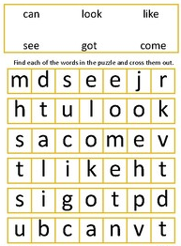
Vowels & List 2 Words (a, e, i, o, u). Circle the vowels in each word.
g o t m e s o t h e y y o u
Fix Me Up
1. the sun woz raining. (3)
2. WhaT iS the time? (2)
Write a sentence (Book)
1. he 2. on 3. them
Mixed Up Words (Starts with the Capital Letter).
No. of Vowels | Mixed Word | Correct
 | tA
 | Thta
Picture Cues (Book)
Write 2 sentences or
8 words for the picture.

Put me in order (Book).
The, a, neck, and, long, giraffe, has, long, legs.

