Board Work 24 (DD) Remember the date (Book).
Maths (after quickfire sheet)
1. If I had $15 and spent $5, how much would I have left?
2. If I had 0 lollies and shared 1/2 with my friend, how many would each of us get?
3. If 2 of us had 10 pencils each, how many pencils would we have altogether?
4. How many minutes are there on a clock between the 6 and the 12 (count in 5’s)?
Handwriting (Book)
II Plus 3 words that start with the letter.

pl Plus 2 words that start with the beginning blend.

r Plus 1 word that ends with the ending letter.
Tuesday and Thursday: Do a border after handwriting.

Word Squares: Write in 2 words or draw 2 pictures for each thing written in the box.
Jandles | Shoes | Gumboots

Alphabetical order (Book) a, b, c, d, e, f, g, h, i, j, k, l, m, n, o, p, q, r, s, t, u, v, w, x, y, z
blue, purple, red, violet, creme
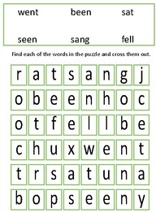
Vowels & List 2 Words (a, e, i, o, u). Circle the vowels in each word.
a t b u t f o r g o t h a d
Fix Me Up
1. what is 4 tea! (3)
2. when is It home Time. (4)
Write a sentence (Book)
1. went 2. for 3. is
Mixed Up Words (Starts with the Capital Letter).
No. of Vowels | Mixed Word | Correct
 | pU
 | Btu
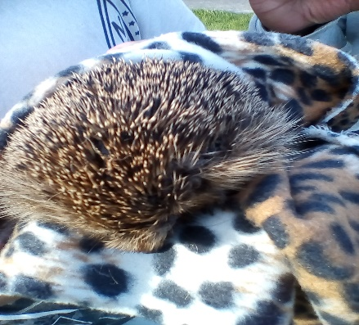
Picture Cues (Book)
Write 2 sentences or
8 words for the picture.

Put me in order (Book).
hedgehog, The, not, very, was, well. feeling

