Board Work – Sheet 4
Below is what you need to do in your books (just like when I wrote it on the board. Just like before, remember to ask if you are not sure of anything, and to watch your neatness and seeting out, include all headings, and underline your headings. Coloured pencil only when including colour.
Don’t forget to put the date.
Maths – F.O.F – All Maths will now be on the board. Start with F.o.F.

Handwriting
stu (go to the end of the line) Plus 5 words for each letter

vwx (go to the end of the line) Plus 5 words for each letter

pr (go to the end of the line) Plus 3 words for each blend

Don’t forget to do your border – Coloured pencil only for colour.
Word Squares
Write in 5 words for each thing written in the box. Allow 10 lines in your book.
Australia | Sweet Foods
Things you listen to | Maths equations that equal 2
Now illustrate (draw) the items you listed in one of the boxes above (coloured pencil or pencil only).

A.O / Syllables
Make up 8 of your own based on things used at school.

Plurals Vs Singular Below are the plural terms (more than 1). Write the singular terms ( 1).
Calves Selves Lives Knives Halves Thieves Shelves Wolves

Reading (LAST)
Choose a story, article or play (not a poem) from one of the School Journals. Read it to yourself, then do the following activities based on it.
1. Title 2. School Journal Part Number and Year (it’s on the front) 3. X3 text Q and A’s
4. X3 picture Q and A’s 5. Author/illustrator 6. X1 Q and A based on the Contents page.
7. Synopsis (what was it about?) 8. Your Opinion (what you thought) 9. Illustration (picture).

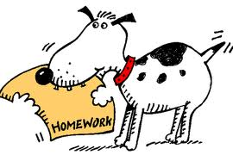
Writing (LAST)

