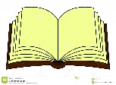**Term 3, 2018 - Contract Work – Job Sheet: Week:**

**Key**

**Name: Day: Date:**

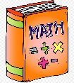****

**Do it in your Everything book**

**Date Quickfire Maths Book exercises**



**Handwriting**

**Do it on the worksheet**

**Blend + 2 words**

**Letter + 4 words**





**Spelling Word Sentences ( List 1 - List 2 - List 4 - List 5 ):**

**1. 2. 3.**

**Do with the class, in your Everything book**



**Mixed Up Words**

**Do with the teacher/buddy**





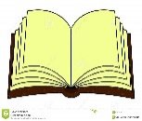

**Cut out and stick in book**

**Writing. Write 3 sentences based on the picture given**

 **to you, or on your own topic.** *Class Own Tchr*

MCj00885580000[1]

**Reading: Book to be written in your Reading Log.**



**Read your reading book**

**Extra Sheet 1:**





**Extra Sheet 2:**



**Use your maths book**

****MCj00885580000[1] **What’s Wrong?**



**Signature**

**Time**



**Fill out your Reading Log**



**Put me in order**