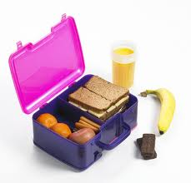
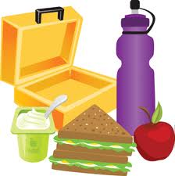

Date: Day: School: Type: Total Roll:
Morning Tea Ends: Lunchtime Begins: Lunchtime Ends:
Number of Lunches Room Tally (lunch numbers from each room): Taken from lunch slips filled out by class teachers.
Room Number
Lunch Orders

Total Number of Lunches that have to be made:
Helpers:
Name | Room | Year/Level | Boy/Girl
- Photos
- USING THE MOST WITH THE LEAST
- Cleaners
- Keeping enough rolls for us
- Handwash
- Going into lunchtime

Notes:
- Special Orders (allergies)
- Safety – carrying knives etc
- Cuts/first aid
- Sharing the different jobs
- Sharing equipment
- This job INCLUDES cleaning and dishes
- Following instructions (stop and listen)
- Any mucking around
- Short meeting at end-we all meet together
- Make a list of what we needed but didn’t have.
Today’s Menu:
Bread roll (white), margarine, luncheon/ham and chicken, lettuce, carrot, cheese, mayonnaise, home baked biscuit

