**A few other notes that may be of use.**

-‘Online Version’ means that the worksheet is done solely on the computer using Microsoft WORD programme.

-Except for the listed words and sentences, the main point is for the child to get used to the actual list words rather than it being about getting all the spelling correct (depending on their ability).

-For the ‘Printable Version’ of the unit, it may also be an idea to enlarge the sheets from A4 to A3 to give the child (especially the younger/less able children) more room to write.

-A blank copy of the worksheet (Teacher Created A1 and A2) has also been attached for the teacher to write in/type in their own ideas/letters/words/images etc.

-A copy of the words from **‘Essential List 3’ (30 words used in 10% of writing)** spelling words has also been included in this resource. These have been included in lighter text so the child can trace over them. All the actual spelling words used in this resource include all of the words from **Essential List 3**. Each contract (A and B) has 5 different words from the list.

Please feel free to use this resource in any way that you see fit with the child/person you are using it with. It is about increasing their confidence, spelling skills and literacy skills. How you do it is up to you. I hope that you find it useful.



**Section 1 – Me, Me, Me, Me**

Children simply fill out all the sections about their personal life. The whole point of this is to get the children familiar in recognising and writing common words/things to do with them so they are familiar with them. Repetition of this section remains the same on all worksheets (except for the ‘something else about me’, where they can write anything else about themselves, such as hair colour, likes, tv programmes, dislikes etc).

**Section 2 – Visual Language/Images**

Children write down what the photo/image shows. Then they write 4 different words about anything to do with the image. They then try to write one or more colours and/or shapes that they can see in the image.

**Section 3 – Handwriting/Letters/Blends**

Children handwrite (or type if doing this on computer) a line based on the lower case, then upper case of the letter shown (just like normal handwriting). Upper (capital) and Lower (small letters) letters are both focussed on. They then do the same based on the blend shown. Then they try to write down three words based on each letter and blend shown.

**Section 4 – Similar Sounds/Endings/Trace the Letters**

Children try to write three words that have the shown letters/parts of a word shown. E.g; ‘ _an’ could be ‘fan, can, pan’. Then they copy the words again in the blue boxes. The letters at the bottom of the page are for the child to trace over. If this is being done as an ‘Online’ worksheet, then the child could do each one different colours on the computer (as they will be unable to physically write on the sheet).

**Section 5 – List 3 (actual Spelling) Words-Word Study**

Each colour is related (so for example, all the green boxes are related to the word in the first green box). Each word/sentence has three boxes. The first has the list word written in black (there are 5 different words from the list). The second box has the same word but done with a lighter colour for the child to trace over. The third box is empty for the child to write/copy the word into that box.

**Section 6 – Mixed Up Sentences**

These boxes are also done using colours and are related to the spelling (list) words originally used in Section 5. The child tries to unscramble the sentence so that it makes sense and is the same as the original sentence in the same coloured box in section 5. The capital letter for the start of the sentence and the full stop at the end of the sentence has also been included for the child to get use to those concepts.

**Section 7 – Odd One Out**

Three of the four words are related and one does not belong. The child says which one is the odd one out and why (there is also a space for the child to also list the colour of the box that the odd word out is in). Depending on the ability of the child, this maybe done orally only and/or may simply be where the child copies the word.

**Signature**

The child writes in their name in the space in the bottom right hand corner.

Name: School:



Class: Year: Age: Day:

Date: Teacher:

Parent name/s:

My Address:

My Phone Number: My Town/City/Area:

My Friends:

Something else about me:

What is it?

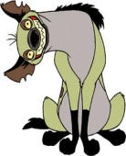

Word 1: Word 2:

Word 3: Word 4:

Colours/Shapes:



**words**

**words**



Copy the words again

**A-B-C-D-E-F-G-H-I-J-K-L-M-N-O-P-Q-R-S-T-U-V-W-X-Y-Z**

Trace / Copy



Read the sentence with the teacher, circle the word used, trace the word, then copy the word into the last box.

A word to do with you (like your name, address etc).

Colour used:



Sign/type

Your name:

Write down which one you think is the odd one out. Remember to say why and what colour box it is in.



Aa Bb Cc Dd

Ee Ff Gg Hh

Ii Jj Kk Ll

Mm Nn Oo Pp

Qq Rr Ss Tt

Uu Vv Ww Xx

Yy Zz



about be go into our after because going just out all came have like said are day her mum some

as down his not were back get

one Home with



Name: School:

Class: Year: Age: Day:

Date: Teacher:

Parent name/s:

My Address:

My Phone Number: My Town/City/Area:

My Friends:

Something else about me:

What is it?

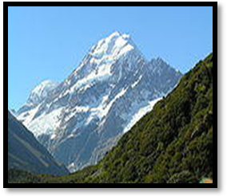

Word 1: Word 2:

Word 3: Word 4:

Colours/Shapes:

**g**



**G**

**fr**

**Gg words**

**fr words**

_ all



Copy the words again

**A-B-C-D-E-F-G-H-I-J-K-L-M-N-O-P-Q-R-S-T-U-V-W-X-Y-Z**

Trace / Copy



into

go

be

about

our

our

into

go

be

about

Read the sentence with the teacher, circle the word used, trace the word, then copy the word into the last box.

I will be there.

I can go fast.

It was about me.

It was about me.

I will be there.

I can go fast.

A word to do with you (like your name, address etc).

. I got into the car.

It was our car.

It was our car.

I got into the car.

Colour used:

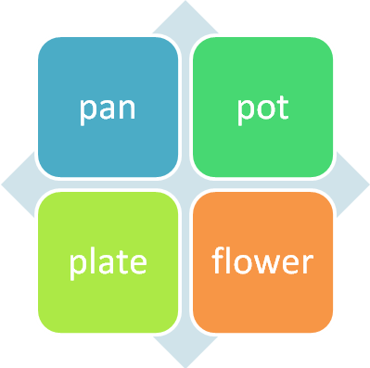

our was It car.

into car the got I

fast. I go can

I be there. will

me. about was It

Sign/type

Your name:

Write down which one you think is the odd one out. Remember to say why and what colour box it is in.

Name: School:



Class: Year: Age: Day:

Date: Teacher:

Parent name/s:

My Address:

My Phone Number: My Town/City/Area:

My Friends:

Something else about me:

What is it?

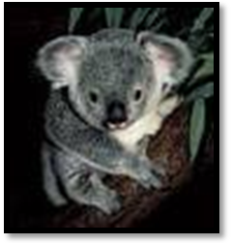

Word 1: Word 2:

Word 3: Word 4:

Colours/Shapes:

**h**



**H**

**gr**

**Hh words**

**gr words**

_ am



Copy the words again

**A-B-C-D-E-F-G-H-I-J-K-L-M-N-O-P-Q-R-S-T-U-V-W-X-Y-Z**



just

going

because

after

out

out

just

going

because

after

Read the sentence with the teacher, circle the word used, trace the word, then copy the word into the last box.

I was hot because the sun was out.

I was going home.

I went after lunch.

I went after lunch.

because the sun was out.

I was going home.

A word to do with you (like your name, address etc).

. He is just about 10.

I let the dog out.

I let the dog out.

He is just about 10.

Colour used:

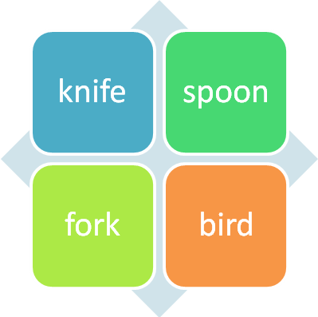

out. the let dog I

10. just is about He

going I home. was

out. was the sun because

lunch. after went I

Sign/type

Your name:

Write down which one you think is the odd one out. Remember to say why and what colour box it is in.

Name: School:



Class: Year: Age: Day:

Date: Teacher:

Parent name/s:

My Address:

My Phone Number: My Town/City/Area:

My Friends:

Something else about me:



What is it?



Word 1: Word 2:

Word 3: Word 4:

Colours/Shapes:

**i**



**I**

**sl**

**Ii words**

**sl words**

_ ill



Copy the words again

**A-B-C-D-E-F-G-H-I-J-K-L-M-N-O-P-Q-R-S-T-U-V-W-X-Y-Z**



like

have

came

all

said

said

like

have

came

all

Read the sentence with the teacher, circle the word used, trace the word, then copy the word into the last box.

The dog came in.

I have a bed.

We are all happy.

We are all happy.

The dog came in.

I have a bed.

A word to do with you (like your name, address etc).

. I like my friends.

I said, “let’s play”.

I said, “let’s play”.

I like my friends.

Colour used:

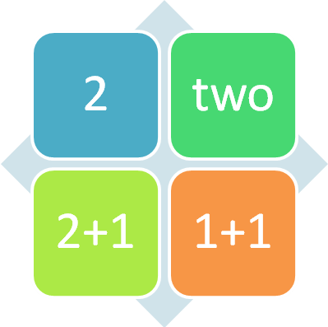

“let’s play”. I said

friends. I my like

a I have bed.

The in. dog came

happy. are all We

Sign/type

Your name:

Write down which one you think is the odd one out. Remember to say why and what colour box it is in.

Name: School:



Class: Year: Age: Day:

Date: Teacher:

Parent name/s:

My Address:

My Phone Number: My Town/City/Area:

My Friends:

Something else about me:

What is it?

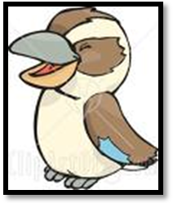

Word 1: Word 2:

Word 3: Word 4:

Colours/Shapes:

**j**



**J**

**tr**

**Jj words**

**tr words**

_ in



Copy the words again

**A-B-C-D-E-F-G-H-I-J-K-L-M-N-O-P-Q-R-S-T-U-V-W-X-Y-Z**



mum

her

day

are

some

some

mum

her

day

are

Read the sentence with the teacher, circle the word used, trace the word, then copy the word into the last box.

The day is sunny.

It is her brush.

We are at school.

We are at school.

The day is sunny.

It is her brush.

A word to do with you (like your name, address etc).

. I have a mum.

Some people are boys.

Some people are boys.

I have a mum.

Colour used:

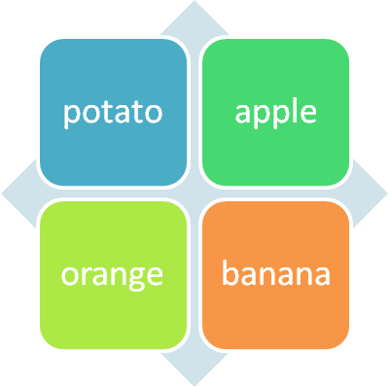

people are Some boys.

Mum. have a I

brush. is her It

The is day sunny.

school. at We are

Sign/type

Your name:

Write down which one you think is the odd one out. Remember to say why and what colour box it is in.

Name: School:



Class: Year: Age: Day:

Date: Teacher:

Parent name/s:

My Address:

My Phone Number: My Town/City/Area:

My Friends:

Something else about me:

What is it?



Word 1: Word 2:

Word 3: Word 4:

Colours/Shapes:

**k**



**K**

**sw**

**Kk words**

**sw words**

_ ice



Copy the words again

**A-B-C-D-E-F-G-H-I-J-K-L-M-N-O-P-Q-R-S-T-U-V-W-X-Y-Z**



not

his

down

as

were

were

not

his

down

as

Read the sentence with the teacher, circle the word used, trace the word, then copy the word into the last box.

I went down the hill.

It was his pencil.

I was as fast as a car.

I was as fast as a car.

I went down the hill.

It was his pencil.

A word to do with you (like your name, address etc).

. I was not hungry.

We were hungry.

We were hungry.

I was not hungry.

Colour used:

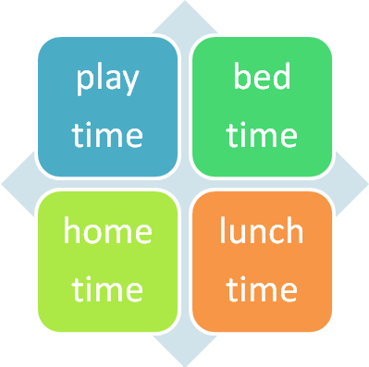

hungry. We were

hungry. I not was

pencil. was It his

I went the down hill.

car. a as fast as was I

Sign/type

Your name:

Write down which one you think is the odd one out. Remember to say why and what colour box it is in.

Name: School:



Class: Year: Age: Day:

Date: Teacher:

Parent name/s:

My Address:

My Phone Number: My Town/City/Area:

My Friends:

Something else about me:

What is it?

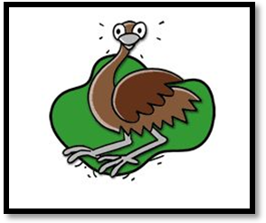

Word 1: Word 2:

Word 3: Word 4:

Colours/Shapes:

**l**



**L**

**st**

**Ll words**

**st words**

_ ing



Copy the words again

**A-B-C-D-E-F-G-H-I-J-K-L-M-N-O-P-Q-R-S-T-U-V-W-X-Y-Z**



one

home

get

back

with

with

one

home

get

back

Read the sentence with the teacher, circle the word used, trace the word, then copy the word into the last box.

I will get the pen.

I ran home.

My back was sore.

My back was sore.

I will get the pen.

I ran home.

A word to do with you (like your name, address etc).

. I had one pencil.

I had one pencil.

I went with my friend.

I went with my friend.

Colour used:

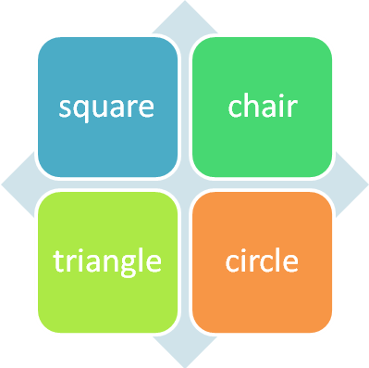

my with went I friend.

one had pencil. I

ran I home.

pen. the get will I

My was sore. back

Sign/type

Your name:

Write down which one you think is the odd one out. Remember to say why and what colour box it is in.