**A few other notes that may be of use.**

-‘Online Version’ means that the worksheet is done solely on the computer using Microsoft WORD programme.

-Except for the listed words and sentences, the main point is for the child to get used to the actual list words rather than it being about getting all the spelling correct (depending on their ability).

-For the ‘Printable Version’ of the unit, it may also be an idea to enlarge the sheets from A4 to A3 to give the child (especially the younger/less able children) more room to write.

-A blank copy of the worksheet (Teacher Created A1 and A2) has also been attached for the teacher to write in/type in their own ideas/letters/words/images etc.

-A copy of the words from **‘Essential List 5’ (50 words used in 5% of writing)** spelling words, letters, and common blends have also been included in this resource. These have been included in lighter text so the child can trace over them. All the actual spelling words used in this resource include all of the words from **Essential List 5**. Each contract (A and B) has 5 different words from the list.

Please feel free to use this resource in any way that you see fit with the child/person you are using it with. It is about increasing their confidence, spelling skills and literacy skills. How you do it is up to you. I hope that you find it useful.



**Section 1 – Me, Me, Me, Me**

Children simply fill out all the sections about their personal life. The whole point of this is to get the children familiar in recognising and writing common words/things to do with them so they are familiar with them. Repetition of this section remains the same on all worksheets (except for the ‘something else about me’, where they can write anything else about themselves, such as hair colour, likes, tv programmes, dislikes etc).

**Section 2 – Visual Language/Images**

Children write down what the photo/image shows. Then they write 4 different words about anything to do with the image. They then try to write one or more colours and/or shapes that they can see in the image.

**Section 3 – Handwriting/Letters/Blends**

Children handwrite (or type if doing this on computer) a line based on the lower case, then upper case of the letter shown (just like normal handwriting). Upper (capital) and Lower (small) letters are both focussed on. They then do the same based on the blend shown. Then they try to write down three words based on each letter and blend shown.

**Section 4 – Similar Sounds/Endings/Trace the Letters**

Children try to write three words that have the shown letters/parts of a word shown. E.g; ‘ _an’ could be ‘fan, can, pan’. Then they copy the words again in the blue boxes. The blends at the bottom of the page are for the child to trace over. If this is being done as an ‘Online’ worksheet, then the child could do each one different colours on the computer (as they will be unable to physically write on the sheet).

**Section 5 – List 5 (actual Spelling) Words-Word Study-Sentences**

Each list word has three boxes. The first has the list word written in black (there are 5 different words from the list). The second box has the same word but done with a lighter colour for the child to trace over. The third box is empty for the child to write/copy the word into that box. Then the child writes each of the list words into full sentences in the below box. They can use more than one word in each sentence as long as it makes sense. Underline the words from the spelling list used in the sentence/s. Remind them that they must also number each sentence, include capitals, full stops, and to use full sentences which describes more than was required in the Lists 1-3 contracts.

**Section 6 – Mixed Up Sentences**

The child chooses any 3 words from the list words (of 5 words) and makes up their own mixed up sentence. This can just be very basic like the ones that were used with the Lists 1-3 Contracts. They write the sentence mixed up in box one, with the answer in the next box.

**Section 7 – Odd One Out**

Three of the four words are related and one does not belong. The child says which one is the odd one out and why (there is also a space for the child to also list the colour of the box that the odd word out is in)

.

**Signature :** The child writes their name in the space in the bottom right hand corner.

Name: School:



D.O.B: Year: Age: Gender:

Date: Principal:

Siblings name/s:

My Address: Postcode:

My Phone Number: My Province:

My Friends:

Something else about me:

What is it of?

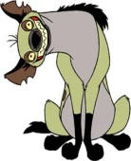

Word 1: Word 2:

Word 3: Word 4:

Colours/Shapes:



**words**

**words**



Copy the words again



Colour used:



Sign/type

Your name:

Write down which one you think is the odd one out. Remember to say why and what colour box it is in.

Aa Bb Cc Dd



Ee Ff Gg Hh

Ii Jj Kk Ll

Mm Nn Oo Pp

Qq Rr Ss Tt

Uu Vv Ww Xx

Yy Zz

bl br cl cr



dr fl fr gl

gr pl pr sc

sk sl sm sn

sp squ st

str sw tr



am door last once

through another play

everyone left told

away family long too

really bed five room

looked walked been

found made something

want before friend



man still way best

fun more thing

where brother here

heard morning name

think which called

thought who car year

know never three

Name: School:



D.O.B: Year: Age: Gender:

Date: Principal:

Siblings name/s:

My Address: Postcode:

My Phone Number: My Province:

My Friends:

Something else about me:



What is it of?



Word 1: Word 2:

Word 3: Word 4:

Colours/Shapes:

**X**



**x**

**sw**

**X words**

**sw words**

...ake



Copy the words again

**Trace the Blends**

**bl, br, cl, cr, dr, fl, fr, gl, gr, pl, pr, sc, sk, sl, sm, sn, sp, squ**



once

last

door

am

through

through

once

last

door

am

Colour used:

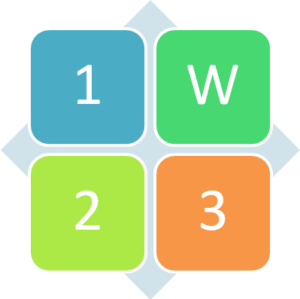

Sign/type

Your name:

Write down which one you think is the odd one out. Remember to say why and what colour box it is in.

Name: School:



D.O.B: Year: Age: Gender:

Date: Principal:

Siblings name/s:

My Address: Postcode:

My Phone Number: My Province:

My Friends:

Something else about me:

What is it of?



Word 1: Word 2:

Word 3: Word 4:

Colours/Shapes:

**Y**



**y**

**str**

**y words**

**str words**

...ank



Copy the words again

**Trace the Blends**

**bl, br, cl, cr, dr, fl, fr, gl, gr, pl, pr, sc, sk, sl, sm, sn, sp, squ**



play

left

everyone

another

told

told

play

left

everyone

another

Colour used:

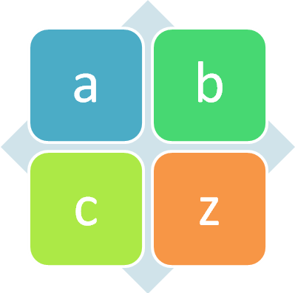

Sign/type

Your name:

Write down which one you think is the odd one out. Remember to say why and what colour box it is in.

Name: School:



D.O.B: Year: Age: Gender:

Date: Principal:

Siblings name/s:

My Address: Postcode:

My Phone Number: My Province:

My Friends:

Something else about me:

What is it of?



Word 1: Word 2:

Word 3: Word 4:

Colours/Shapes:

**Z**



**z**

**st**

**Z words**

**st words**

...ar



Copy the words again

**Trace the Blends**

**bl, br, cl, cr, dr, fl, fr, gl, gr, pl, pr, sc, sk, sl, sm, sn, sp, squ**



really

long

family

away

too

too

really

long

family

away

Colour used:

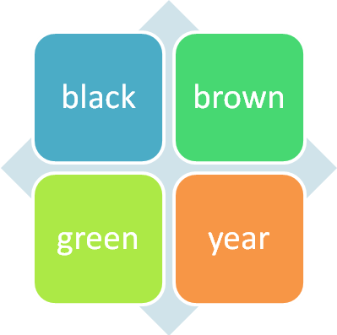

Sign/type

Your name:

Write down which one you think is the odd one out. Remember to say why and what colour box it is in.

Name: School:



D.O.B: Year: Age: Gender:

Date: Principal:

Siblings name/s:

My Address: Postcode:

My Phone Number: My Province:

My Friends:

Something else about me:

What is it of?



Word 1: Word 2:

Word 3: Word 4:

Colours/Shapes:

**A**



**B**

**squ**

**b words**

**squ words**

...ash



Copy the words again

**Trace the Blends**

**bl, br, cl, cr, dr, fl, fr, gl, gr, pl, pr, sc, sk, sl, sm, sn, sp, squ**



room

looked

five

bed

walked

walked

room

looked

five

bed

Colour used:

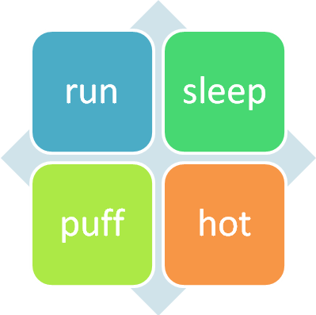

Sign/type

Your name:

Write down which one you think is the odd one out. Remember to say why and what colour box it is in.

Name: School:



D.O.B: Year: Age: Gender:

Date: Principal:

Siblings name/s:

My Address: Postcode:

My Phone Number: My Province:

My Friends:

Something else about me:

What is it of?



Word 1: Word 2:

Word 3: Word 4:

Colours/Shapes:

**C**



**D**

**sp**

**D words**

**sp words**

...ight



Copy the words again

**Trace the Blends**

**bl, br, cl, cr, dr, fl, fr, gl, gr, pl, pr, sc, sk, sl, sm, sn, sp, squ**



something

made

found

been

want

want

something

made

found

been

Colour used:

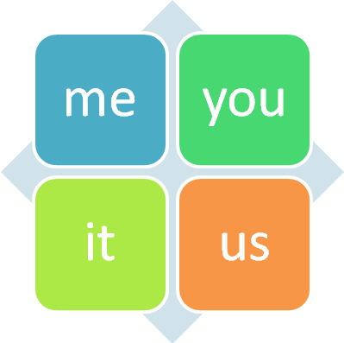

Sign/type

Your name:

Write down which one you think is the odd one out. Remember to say why and what colour box it is in.

Name: School:



D.O.B: Year: Age: Gender:

Date: Principal:

Siblings name/s:

My Address: Postcode:

My Phone Number: My Province:

My Friends:

Something else about me:



What is it of?



Word 1: Word 2:

Word 3: Word 4:

Colours/Shapes:

**E**



**F**

**sn**

**F words**

**sn words**

...ip



Copy the words again

**Trace the Blends**

**bl, br, cl, cr, dr, fl, fr, gl, gr, pl, pr, sc, sk, sl, sm, sn, sp, squ**



still

man

friend

before

way

way

still

man

friend

before

Colour used:

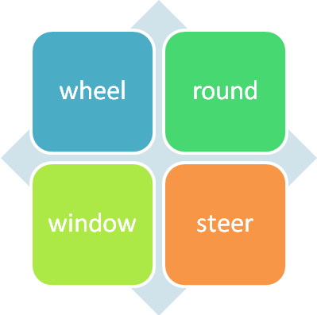

Sign/type

Your name:

Write down which one you think is the odd one out. Remember to say why and what colour box it is in.

Name: School:



D.O.B: Year: Age: Gender:

Date: Principal:

Siblings name/s:

My Address: Postcode:

My Phone Number: My Province:

My Friends:

Something else about me:



What is it of?



Word 1: Word 2:

Word 3: Word 4:

Colours/Shapes:

**G**



**H**

**sm**

**G words**

**sm words**

...og



Copy the words again

**Trace the Blends**

**bl, br, cl, cr, dr, fl, fr, gl, gr, pl, pr, sc, sk, sl, sm, sn, sp, squ**



thing

more

fun

best

where

where

thing

more

fun

best

Colour used:

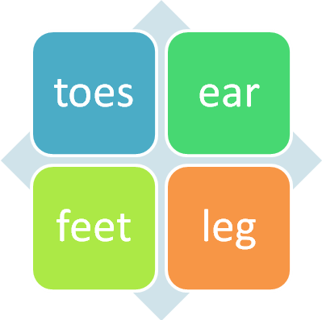

Sign/type

Your name:

Write down which one you think is the odd one out. Remember to say why and what colour box it is in.

Name: School:



D.O.B: Year: Age: Gender:

Date: Principal:

Siblings name/s:

My Address: Postcode:

My Phone Number: My Province:

My Friends:

Something else about me:

What is it of?



Word 1: Word 2:

Word 3: Word 4:

Colours/Shapes:

**I**



**J**

**sl**

**j words**

**sl words**

...oke



Copy the words again

**Trace the Blends**

**bl, br, cl, cr, dr, fl, fr, gl, gr, pl, pr, sc, sk, sl, sm, sn, sp, squ**



think

morning

heard

brother

which

which

think

morning

heard

brother

Colour used:

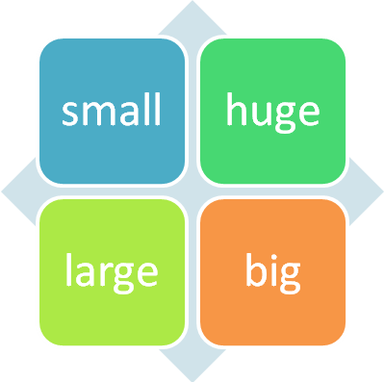

Sign/type

Your name:

Write down which one you think is the odd one out. Remember to say why and what colour box it is in.

Name: School:



D.O.B: Year: Age: Gender:

Date: Principal:

Siblings name/s:

My Address: Postcode:

My Phone Number: My Province:

My Friends:

Something else about me:



What is it of?



Word 1: Word 2:

Word 3: Word 4:

Colours/Shapes:

**K**



**L**

**sk**

**K words**

**sk words**

...ump



Copy the words again

**Trace the Blends**

**bl, br, cl, cr, dr, fl, fr, gl, gr, pl, pr, sc, sk, sl, sm, sn, sp, squ**



thought

name

here

called

who

who

thought

name

here

called

Colour used:

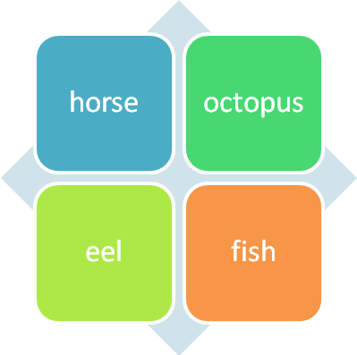

Sign/type

Your name:

Write down which one you think is the odd one out. Remember to say why and what colour box it is in.

Name: School:



D.O.B: Year: Age: Gender:

Date: Principal:

Siblings name/s:

My Address: Postcode:

My Phone Number: My Province:

My Friends:

Something else about me:



What is it of?



Word 1: Word 2:

Word 3: Word 4:

Colours/Shapes:

**M**



**N**

**pr**

**M words**

**N words**

...unk



Copy the words again

**Trace the Blends**

**bl, br, cl, cr, dr, fl, fr, gl, gr, pl, pr, sc, sk, sl, sm, sn, sp, squ**



three

never

know

car

year

year

three

never

know

car

Colour used:

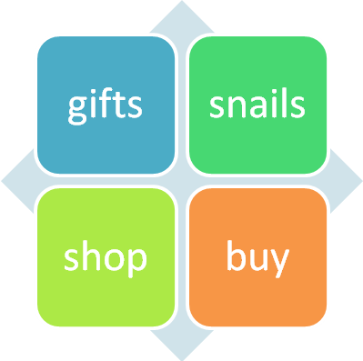

Sign/type

Your name:

Write down which one you think is the odd one out. Remember to say why and what colour box it is in.