**A few other notes that may be of use.**

-‘Online Version’ means that the worksheet is done solely on the computer using Microsoft WORD programme.

-Except for the listed words and sentences, the main point is for the child to get used to the actual list words rather than it being about getting all the spelling correct (depending on their ability).

-For the ‘Printable Version’ of the unit, it may also be an idea to enlarge the sheets from A4 to A3 to give the child (especially the younger/less able children) more room to write.

-A blank copy of the worksheet (Teacher Created A1 and A2) has also been attached for the teacher to write in/type in their own ideas/letters/words/images etc.

-A copy of the words from **‘Essential List 6’ (70 words; 5% of writing)** spelling words, letters, and common blends have also been included in this resource. These have been included in lighter text so the child can trace over them. All the actual spelling words used in this resource include all of the words from **Essential List 6**. Each contract (A and B) has 5 different words from the list.

Please feel free to use this resource in any way that you see fit with the child/person you are using it with. It is about increasing their confidence, spelling skills and literacy skills. How you do it is up to you. I hope that you find it useful.



**Section 1 – Me, Me, Me, Me**

Children simply fill out all the sections about their personal life. The whole point of this is to get the children familiar in recognising and writing common words/things to do with them so they are familiar with them. Repetition of this section remains the same on all worksheets (except for the ‘something else about me’, where they can write anything else about themselves, such as hair colour, likes, tv programmes, dislikes etc).

**Section 2 – Visual Language/Images**

Children write down what the photo/image shows. Then they write 4 different words about anything to do with the image. They then try to write one or more colours and/or shapes that they can see in the image.

**Section 3 – Handwriting/Letters/Blends**

Children handwrite (or type if doing this on computer) a line based on the lower case, then upper case of the letter shown (just like normal handwriting). Upper (capital) and Lower (small) letters are both focussed on. They then do the same based on the blend shown. Then they try to write down three words based on each letter and blend shown.

**Section 4 – Similar Sounds/Endings/Trace the Letters**

Children try to write three words that have the shown letters/parts of a word shown. E.g; ‘ _an’ could be ‘fan, can, pan’. Then they copy the words again in the blue boxes. The blends at the bottom of the page are for the child to trace over. If this is being done as an ‘Online’ worksheet, then the child could do each one different colours on the computer (as they will be unable to physically write on the sheet).

**Section 5 – List 6 (actual Spelling) Words-Word Study-Sentences**

Each list word has three boxes. The first has the list word written in black (there are 5 different words from the list). The second box has the same word but done with a lighter colour for the child to trace over. The third box is empty for the child to write/copy the word into that box. Then the child writes each of the list words into full sentences in the below box. They can use more than one word in each sentence as long as it makes sense. Underline the words from the spelling list used in the sentence/s. Remind them that they must also number each sentence, include capitals, full stops, and to use full sentences which describes more than was required in the Lists 1-3 contracts.

**Section 6 – Mixed Up Sentences**

The child chooses any 3 words from the list words (of 5 words) and makes up their own mixed up sentence. This can just be very basic like the ones that were used with the Lists 1-3 Contracts. They write the sentence mixed up in box one, with the answer in the next box.

**Section 7 – Odd One Out**

Three of the four words are related and one does not belong. The child says which one is the odd one out and why (there is also a space for the child to also list the colour of the box that the odd word out is in)

.

**Signature :** The child writes their name in the space in the bottom right hand corner.

Name: School:



D.O.B: Year: Age: Gender:

Date: Principal:

Siblings name/s:

My Address: Postcode:

My Phone Number: My Province:

My Friends:

Something else about me:

What is it of?

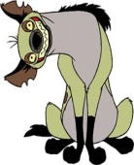

Word 1: Word 2:

Word 3: Word 4:

Colours/Shapes:



**words**

**words**



Copy the words again

**bl, br, cl, cr, dr, fl, fr, gl, gr, pl, pr, sc, sk, sl, sm, sn, sp, squ**



Write down which one you think is the odd one out. Remember to say why and what colour box it is in.

Colour used:



Sign/type

Your name:

Aa Bb Cc Dd



Ee Ff Gg Hh

Ii Jj Kk Ll

Mm Nn Oo Pp

Qq Rr Ss Tt

Uu Vv Ww Xx

Yy Zz

bl br cl cr



dr fl fr gl

gr pl pr sc

sk sl sm sn

sp squ st

str sw tr



also cool eyes head

jump always dark

fell hit knew asked

decided felt how

later black dog find

inside life boy eat

four its live bus

end gave it’s lot



cat even getting I’ll

lunch coming every

great I’m make top

coming place sister

water most ready

sleep town while

much ride suddenly



tree why nice right

take turned tell

window opened run

until woke outside

say ten wanted

yes

Name: School:



D.O.B: Year: Age: Gender:

Date: Principal:

Siblings name/s:

My Address: Postcode:

My Phone Number: My Province:

My Friends:

Something else about me:

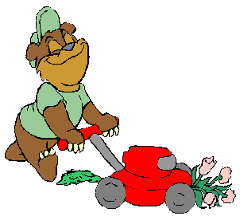

What is it of?



Word 1: Word 2:

Word 3: Word 4:

Colours/Shapes:

**W**



**w**

**tr**

**w words**

**tr words**

...ain



Copy the words again

**bl, br, cl, cr, dr, fl, fr, gl, gr, pl, pr, sc, sk, sl, sm, sn, sp, squ**



head

eyes

cool

also

jump

jump

head

eyes

cool

also

Write down which one you think is the odd one out. Remember to say why and what colour box it is in.

Colour used:

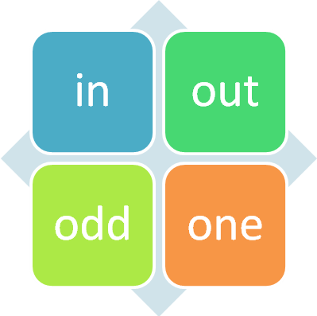

Sign/type

Your name:

Name: School:



D.O.B: Year: Age: Gender:

Date: Principal:

Siblings name/s:

My Address: Postcode:

My Phone Number: My Province:

My Friends:

Something else about me:



What is it of?



Word 1: Word 2:

Word 3: Word 4:

Colours/Shapes:

**m**



**n**

**pr**

**N words**

**pr words**

...unk



Copy the words again

**bl, br, cl, cr, dr, fl, fr, gl, gr, pl, pr, sc, sk, sl, sm, sn, sp, squ**



hit

fell

dark

always

knew

knew

hit

fell

dark

always

Write down which one you think is the odd one out. Remember to say why and what colour box it is in.

Colour used:

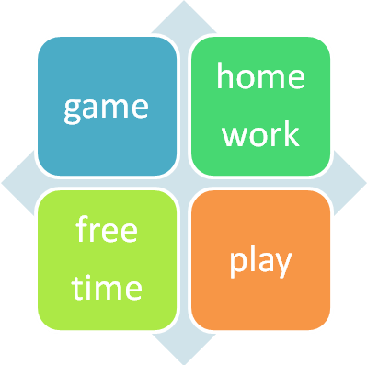

Sign/type

Your name:

Name: School:



D.O.B: Year: Age: Gender:

Date: Principal:

Siblings name/s:

My Address: Postcode:

My Phone Number: My Province:

My Friends:

Something else about me:

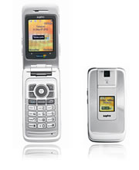

What is it of?



Word 1: Word 2:

Word 3: Word 4:

Colours/Shapes:

**o**



**p**

**sc**

**o words**

**sc words**

...eel



Copy the words again

**bl, br, cl, cr, dr, fl, fr, gl, gr, pl, pr, sc, sk, sl, sm, sn, sp, squ**



how

felt

decided

asked

later

later

how

felt

decided

asked

Write down which one you think is the odd one out. Remember to say why and what colour box it is in.

Colour used:

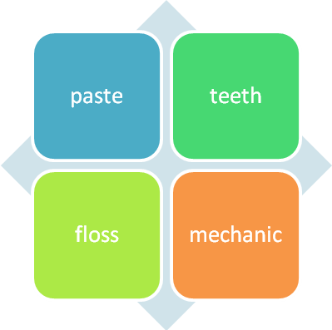

Sign/type

Your name:

Name: School:



D.O.B: Year: Age: Gender:

Date: Principal:

Siblings name/s:

My Address: Postcode:

My Phone Number: My Province:

My Friends:

Something else about me:

What is it of?



Word 1: Word 2:

Word 3: Word 4:

Colours/Shapes:

**q**



**r**

**pl**

**r words**

**pl words**

...eep



Copy the words again

**bl, br, cl, cr, dr, fl, fr, gl, gr, pl, pr, sc, sk, sl, sm, sn, sp, squ**



inside

find

dog

black

life

life

inside

find

dog

black

Write down which one you think is the odd one out. Remember to say why and what colour box it is in.

Colour used:

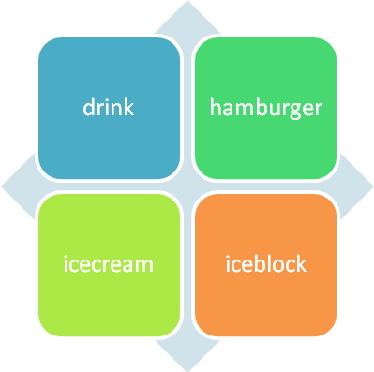

Sign/type

Your name:

Name: School:



D.O.B: Year: Age: Gender:

Date: Principal:

Siblings name/s:

My Address: Postcode:

My Phone Number: My Province:

My Friends:

Something else about me:



What is it of?



Word 1: Word 2:

Word 3: Word 4:

Colours/Shapes:

**s**



**t**

**gr**

**t words**

**gr words**

...eet



Copy the words again

**bl, br, cl, cr, dr, fl, fr, gl, gr, pl, pr, sc, sk, sl, sm, sn, sp, squ**



its

four

eat

boy

live

live

its

four

eat

boy

Write down which one you think is the odd one out. Remember to say why and what colour box it is in.

Colour used:

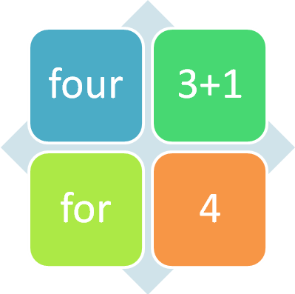

Sign/type

Your name:

Name: School:



D.O.B: Year: Age: Gender:

Date: Principal:

Siblings name/s:

My Address: Postcode:

My Phone Number: My Province:

My Friends:

Something else about me:



What is it of?



Word 1: Word 2:

Word 3: Word 4:

Colours/Shapes:

**u**



**v**

**gl**

**u words**

**gl words**

...en



Copy the words again

**bl, br, cl, cr, dr, fl, fr, gl, gr, pl, pr, sc, sk, sl, sm, sn, sp, squ**



it’s

gave

end

bus

lot

lot

it’s

gave

end

bus

Write down which one you think is the odd one out. Remember to say why and what colour box it is in.

Colour used:

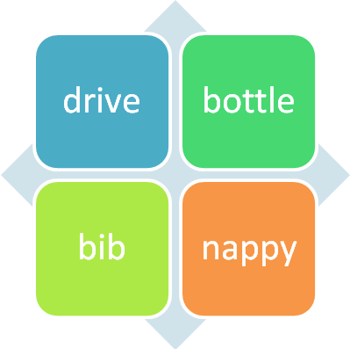

Sign/type

Your name:

Name: School:



D.O.B: Year: Age: Gender:

Date: Principal:

Siblings name/s:

My Address: Postcode:

My Phone Number: My Province:

My Friends:

Something else about me:



What is it of?



Word 1: Word 2:

Word 3: Word 4:

Colours/Shapes:

**w**



**x**

**fr**

**w words**

**fr words**

...est



Copy the words again

**bl, br, cl, cr, dr, fl, fr, gl, gr, pl, pr, sc, sk, sl, sm, sn, sp, squ**



I’ll

getting

even

cat

lunch

lunch

I’ll

getting

even

cat

Write down which one you think is the odd one out. Remember to say why and what colour box it is in.

Colour used:

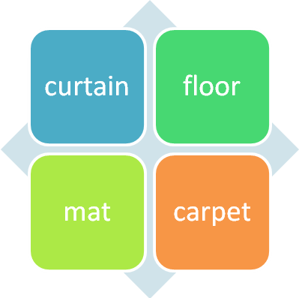

Sign/type

Your name:

Name: School:



D.O.B: Year: Age: Gender:

Date: Principal:

Siblings name/s:

My Address: Postcode:

My Phone Number: My Province:

My Friends:

Something else about me:

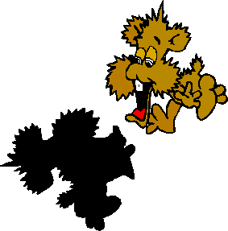

What is it of?



Word 1: Word 2:

Word 3: Word 4:

Colours/Shapes:

**y**



**z**

**fl**

**y words**

**fl words**

...ide



Copy the words again

**bl, br, cl, cr, dr, fl, fr, gl, gr, pl, pr, sc, sk, sl, sm, sn, sp, squ**



I’m

great

every

coming

make

make

I’m

great

every

coming

Write down which one you think is the odd one out. Remember to say why and what colour box it is in.

Colour used:

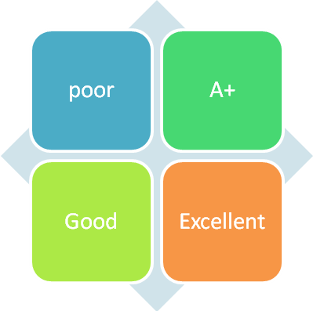

Sign/type

Your name:

Name: School:



D.O.B: Year: Age: Gender:

Date: Principal:

Siblings name/s:

My Address: Postcode:

My Phone Number: My Province:

My Friends:

Something else about me:

What is it of?

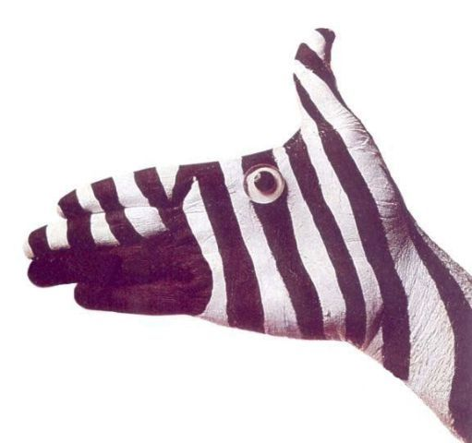

Word 1: Word 2:

Word 3: Word 4:

Colours/Shapes:

**a**



**b**

**dr**

**b words**

**dr words**

...ile



Copy the words again

**bl, br, cl, cr, dr, fl, fr, gl, gr, pl, pr, sc, sk, sl, sm, sn, sp, squ**



top

sister

place

minutes

water

water

top

sister

place

minutes

Write down which one you think is the odd one out. Remember to say why and what colour box it is in.

Colour used:

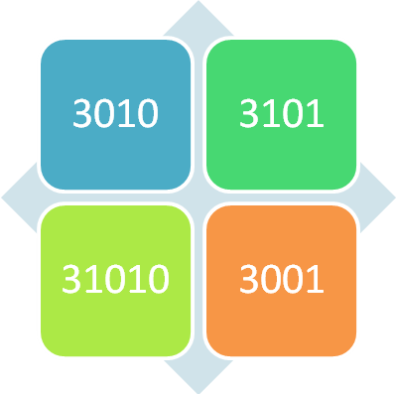

Sign/type

Your name:

Name: School:



D.O.B: Year: Age: Gender:

Date: Principal:

Siblings name/s:

My Address: Postcode:

My Phone Number: My Province:

My Friends:

Something else about me:

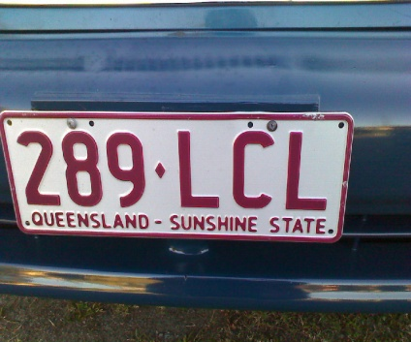

What is it of?



Word 1: Word 2:

Word 3: Word 4:

Colours/Shapes:

**c**



**d**

**cr**

**d words**

**cr words**

...ine



Copy the words again

**bl, br, cl, cr, dr, fl, fr, gl, gr, pl, pr, sc, sk, sl, sm, sn, sp, squ**



town

sleep

ready

most

while

while

town

sleep

ready

most

Write down which one you think is the odd one out. Remember to say why and what colour box it is in.

Colour used:

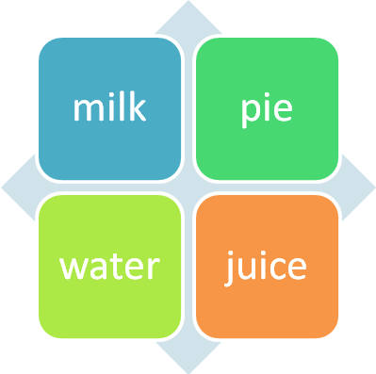

Sign/type

Your name:

Name: School:



D.O.B: Year: Age: Gender:

Date: Principal:

Siblings name/s:

My Address: Postcode:

My Phone Number: My Province:

My Friends:

Something else about me:

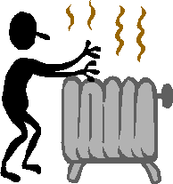

What is it of?



Word 1: Word 2:

Word 3: Word 4:

Colours/Shapes:

**e**



**f**

**cl**

**f words**

**cl words**

...ink



Copy the words again

**bl, br, cl, cr, dr, fl, fr, gl, gr, pl, pr, sc, sk, sl, sm, sn, sp, squ**



tree

suddenly

ride

much

why

why

tree

suddenly

ride

much

Write down which one you think is the odd one out. Remember to say why and what colour box it is in.

Colour used:

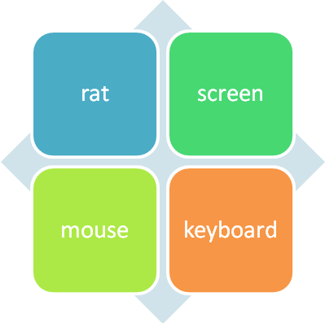

Sign/type

Your name:

Name: School:



D.O.B: Year: Age: Gender:

Date: Principal:

Siblings name/s:

My Address: Postcode:

My Phone Number: My Province:

My Friends:

Something else about me:

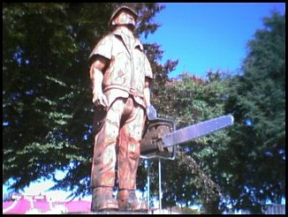

What is it of?



Word 1: Word 2:

Word 3: Word 4:

Colours/Shapes:

**g**



**h**

**br**

**g words**

**br words**

...oil



Copy the words again

**bl, br, cl, cr, dr, fl, fr, gl, gr, pl, pr, sc, sk, sl, sm, sn, sp, squ**



turned

take

right

nice

window

window

turned

take

right

nice

Write down which one you think is the odd one out. Remember to say why and what colour box it is in.

Colour used:

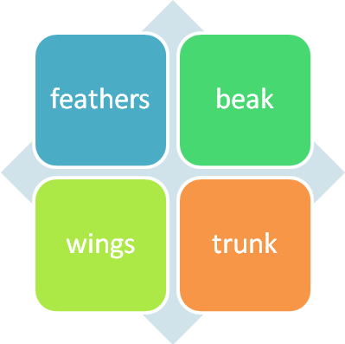

Sign/type

Your name:

Name: School:



D.O.B: Year: Age: Gender:

Date: Principal:

Siblings name/s:

My Address: Postcode:

My Phone Number: My Province:

My Friends:

Something else about me:

What is it of?



Word 1: Word 2:

Word 3: Word 4:

Colours/Shapes:

**i**



**j**

**bl**

**i words**

**bl words**

...op



Copy the words again

**bl, br, cl, cr, dr, fl, fr, gl, gr, pl, pr, sc, sk, sl, sm, sn, sp, squ**



until

tell

run

opened

woke

woke

until

tell

run

opened

Write down which one you think is the odd one out. Remember to say why and what colour box it is in.

Colour used:

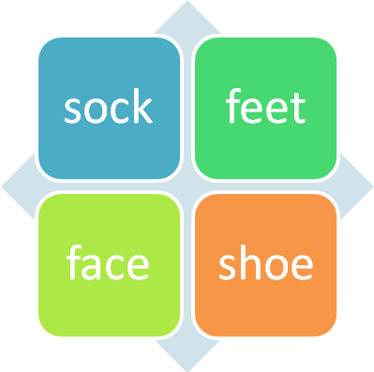

Sign/type

Your name:

Name: School:



D.O.B: Year: Age: Gender:

Date: Principal:

Siblings name/s:

My Address: Postcode:

My Phone Number: My Province:

My Friends:

Something else about me:

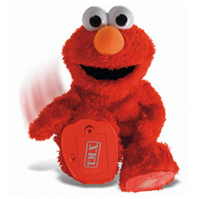

What is it of?



Word 1: Word 2:

Word 3: Word 4:

Colours/Shapes:

**k**



**L**

**str**

**L words**

**str words**

...ug



Copy the words again

**bl, br, cl, cr, dr, fl, fr, gl, gr, pl, pr, sc, sk, sl, sm, sn, sp, squ**



wanted

ten

say

outside

yes

yes

wanted

ten

say

outside

Write down which one you think is the odd one out. Remember to say why and what colour box it is in.

Colour used:

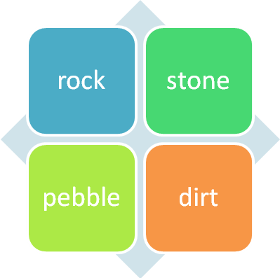

Sign/type

Your name: