**A few other notes that may be of use.**

-‘Online Version’ means that the worksheet is done solely on the computer using Microsoft WORD programme.

-Except for the listed words and sentences, the main point is for the child to get used to the actual list words rather than it being about getting all the spelling correct (depending on their ability).

-For the ‘Printable Version’ of the unit, it may also be an idea to enlarge the sheets from A4 to A3 to give the child (especially the younger/less able children) more room to write.

-A blank copy of the worksheet (Teacher Created A1 and A2) has also been attached for the teacher to write in/type in their own ideas/letters/words/images etc.

-A copy of the words from **‘Essential List 7’ (60 words; 3% of writing)** spelling words, letters, and common blends have also been included in this resource. These have been included in lighter text so the child can trace over them. All the actual spelling words used in this resource include all of the words from **Essential List 7**. Each contract (A and B) has 5 different words from the list.

Please feel free to use this resource in any way that you see fit with the child/person you are using it with. It is about increasing their confidence, spelling skills and literacy skills. How you do it is up to you. I hope that you find it useful.



**Section 1 – Me, Me, Me, Me**

Children make up their own headings and information in the box based along the same lines as was used in previous contracts (Lists 1 – 6). Headings will be their/the teachers choice.

**Section 2 – Visual Language/Images**

Children write down what the photo/image shows. Then they write 4 different words about anything to do with the image. They then try to write one or more colours and/or shapes that they can see in the image.

**Section 3 – Final Consonants**

Children try to write three words that have the shown final consonants in the words. Then they copy the words again into the blue boxes. The final consonants at the bottom of the page are for the child to trace over. If this is being done as an ‘Online’ worksheet, then the child could do each one different colours on the computer (as they will be unable to physically write on the sheet).

**Section 4 – List 7 (final list) (actual Spelling) Words-Word Study-Sentences**

Each list word has three boxes. The first has the list word written in black (there are 5 different words from the list). The second box has the same word but done with a lighter colour for the child to trace over. The third box is empty for the child to write/copy the word into that box. Then the child writes each of the list words into full sentences in the below box. They can use more than one word in each sentence as long as it makes sense. Underline the words from the spelling list used in the sentence/s. Remind them that they must also number each sentence, include capitals, full stops, and to use full sentences which describes more than was required in the previous Essential List contracts.

**Section 5 – Odd One Out**

Three of the four words are related and one does not belong. The child says which one is the odd one out and why. Then they try to use all words in a sentence/s in the same box to show understanding of the words used.

.

**Signature**

The child writes their name in the space in the bottom right hand corner.

Name: Class and Date:

Children make up their own headings and information in the below box based along the same lines as was used in previous contracts (Lists 1 – 6)



What is it of?

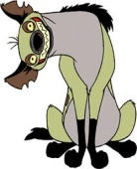

Word 1: Word 2:

Word 3: Word 4:

Colours/Shapes:



Copy the words again



1. Write down which one you think is the odd one out. Remember to say why you think it is the odd one out (justify). 2. Put each word into a sentence.

Sign/type

Your name:

Aa Bb Cc Dd



Ee Ff Gg Hh

Ii Jj Kk Ll

Mm Nn Oo Pp

Qq Rr Ss Tt

Uu Vv Ww Xx

Yy Zz

bl br cl cr



dr fl fr gl

gr pl pr sc

sk sl sm sn

sp squ st

str sw tr



any each ground soon

money baby ever bad

guard mother stay

everything hand stop

myself ball face new

happened swimming bit

being fast happy tea

parents father help



picked than boat few

hole playing tried

bought finally hot world

presents under camp

finished hour road

wait dead game let

side won died girl

look small work doing

gone many sometimes

Name: Class and Date:

Children make up their own headings and information in the below box based along the same lines as was used in previous contracts (Lists 1 – 6)



What is it of?



Word 1: Word 2:

Word 3: Word 4:

Colours/Shapes:



...lt

Copy the words again

**-ct, -ft, -lb, -lt, -mp, -nd, -ng, -nk, -nt, -pt, -sk, -sp, -st**



money

ground

each

any

soon

soon

money

ground

each

any

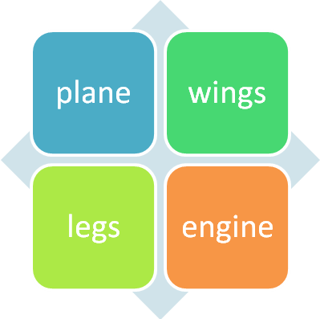

1. Write down which one you think is the odd one out. Remember to say why you think it is the odd one out (justify). 2. Put each word into a sentence.

Sign/type

Your name:

Name: Class and Date:

Children make up their own headings and information in the below box based along the same lines as was used in previous contracts (Lists 1 – 6)



What is it of?



Word 1: Word 2:

Word 3: Word 4:

Colours/Shapes:



...st

Copy the words again

**-ct, -ft, -lb, -lt, -mp, -nd, -ng, -nk, -nt, -pt, -sk, -sp, -st**



mother

guard

ever

baby

stay

stay

mother

guard

ever

baby

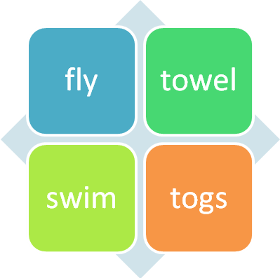

1. Write down which one you think is the odd one out. Remember to say why you think it is the odd one out (justify). 2. Put each word into a sentence.

Sign/type

Your name:

Name: Class and Date:

Children make up their own headings and information in the below box based along the same lines as was used in previous contracts (Lists 1 – 6)

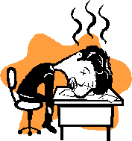

What is it of?



Word 1: Word 2:

Word 3: Word 4:

Colours/Shapes:



...sp

Copy the words again

**-ct, -ft, -lb, -lt, -mp, -nd, -ng, -nk, -nt, -pt, -sk, -sp, -st**



myself

hand

everything

bad

stop

stop

myself

hand

everything

bad

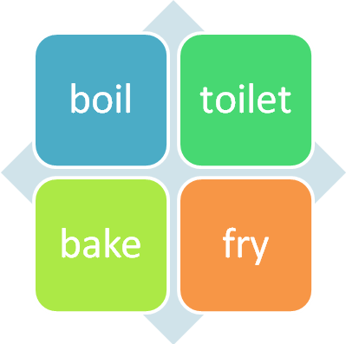

1. Write down which one you think is the odd one out. Remember to say why you think it is the odd one out (justify). 2. Put each word into a sentence.

Sign/type

Your name:

Name: Class and Date:

Children make up their own headings and information in the below box based along the same lines as was used in previous contracts (Lists 1 – 6)



What is it of?

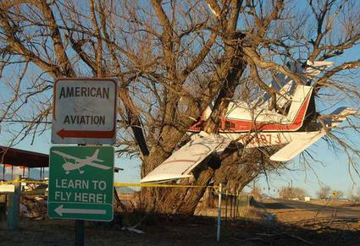

Word 1: Word 2:

Word 3: Word 4:

Colours/Shapes:



...sk

Copy the words again

**-ct, -ft, -lb, -lt, -mp, -nd, -ng, -nk, -nt, -pt, -sk, -sp, -st**



new

happened

face

ball

swimming

swimming

new

happened

face

ball

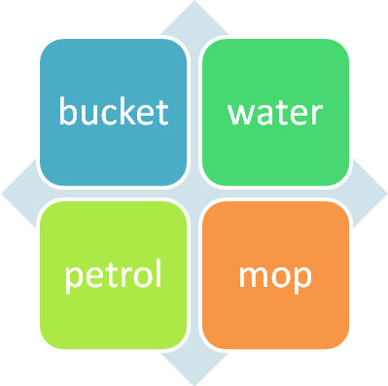

1. Write down which one you think is the odd one out. Remember to say why you think it is the odd one out (justify). 2. Put each word into a sentence.

Sign/type

Your name:

Name: Class and Date:

Children make up their own headings and information in the below box based along the same lines as was used in previous contracts (Lists 1 – 6)



What is it of?

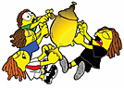

Word 1: Word 2:

Word 3: Word 4:

Colours/Shapes:



...pt

Copy the words again

**-ct, -ft, -lb, -lt, -mp, -nd, -ng, -nk, -nt, -pt, -sk, -sp, -st**



parents

happy

fast

being

tea

tea

parents

happy

fast

being

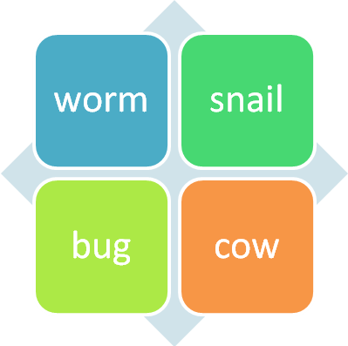

1. Write down which one you think is the odd one out. Remember to say why you think it is the odd one out (justify). 2. Put each word into a sentence.

Sign/type

Your name:

Name: Class and Date:

Children make up their own headings and information in the below box based along the same lines as was used in previous contracts (Lists 1 – 6)



What is it of?

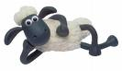

Word 1: Word 2:

Word 3: Word 4:

Colours/Shapes:



...nt

Copy the words again

**-ct, -ft, -lb, -lt, -mp, -nd, -ng, -nk, -nt, -pt, -sk, -sp, -st**



picked

help

father

bit

than

than

picked

help

father

bit

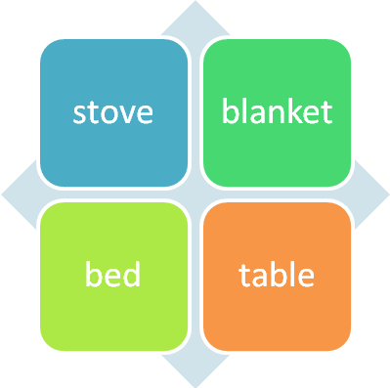

1. Write down which one you think is the odd one out. Remember to say why you think it is the odd one out (justify). 2. Put each word into a sentence.

Sign/type

Your name:

Name: Class and Date:

Children make up their own headings and information in the below box based along the same lines as was used in previous contracts (Lists 1 – 6)



What is it of?



Word 1: Word 2:

Word 3: Word 4:

Colours/Shapes:



...nk

Copy the words again

**-ct, -ft, -lb, -lt, -mp, -nd, -ng, -nk, -nt, -pt, -sk, -sp, -st**



playing

hole

few

boat

tried

tried

playing

hole

few

boat

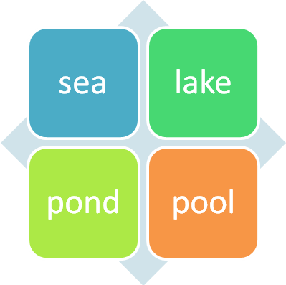

1. Write down which one you think is the odd one out. Remember to say why you think it is the odd one out (justify). 2. Put each word into a sentence.

Sign/type

Your name:

Name: Class and Date:

Children make up their own headings and information in the below box based along the same lines as was used in previous contracts (Lists 1 – 6)



What is it of?



Word 1: Word 2:

Word 3: Word 4:

Colours/Shapes:



...ng

Copy the words again

**-ct, -ft, -lb, -lt, -mp, -nd, -ng, -nk, -nt, -pt, -sk, -sp, -st**



presents

hot

finally

bought

under

under

presents

hot

finally

bought

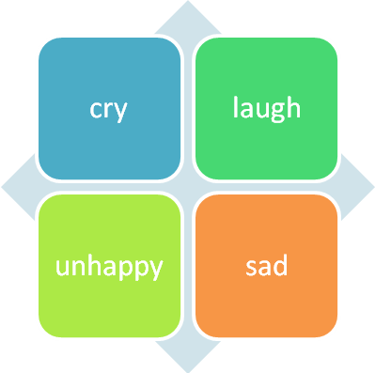

1. Write down which one you think is the odd one out. Remember to say why you think it is the odd one out (justify). 2. Put each word into a sentence.

Sign/type

Your name:

Name: Class and Date:

Children make up their own headings and information in the below box based along the same lines as was used in previous contracts (Lists 1 – 6)



What is it of?



Word 1: Word 2:

Word 3: Word 4:

Colours/Shapes:



...nd

Copy the words again

**-ct, -ft, -lb, -lt, -mp, -nd, -ng, -nk, -nt, -pt, -sk, -sp, -st**



road

hour

finished

camp

wait

wait

road

hour

finished

camp

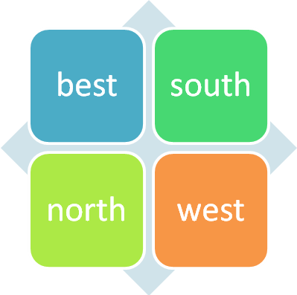

1. Write down which one you think is the odd one out. Remember to say why you think it is the odd one out (justify). 2. Put each word into a sentence.

Sign/type

Your name:

Name: Class and Date:

Children make up their own headings and information in the below box based along the same lines as was used in previous contracts (Lists 1 – 6)



What is it of?



Word 1: Word 2:

Word 3: Word 4:

Colours/Shapes:



...mp

Copy the words again

**-ct, -ft, -lb, -lt, -mp, -nd, -ng, -nk, -nt, -pt, -sk, -sp, -st**



side

let

game

dead

won

won

side

let

game

dead

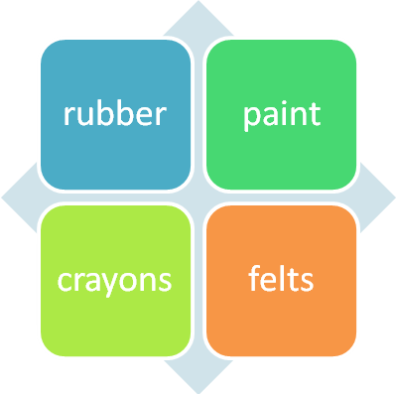

1. Write down which one you think is the odd one out. Remember to say why you think it is the odd one out (justify). 2. Put each word into a sentence.

Sign/type

Your name:

Name: Class and Date:

Children make up their own headings and information in the below box based along the same lines as was used in previous contracts (Lists 1 – 6)



What is it of?



Word 1: Word 2:

Word 3: Word 4:

Colours/Shapes:



...ft

Copy the words again

**-ct, -ft, -lb, -lt, -mp, -nd, -ng, -nk, -nt, -pt, -sk, -sp, -st**



small

look

girl

died

work

work

small

look

girl

died

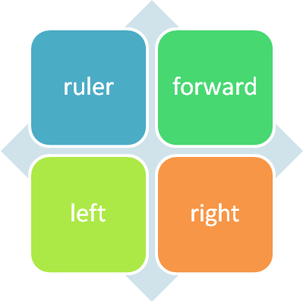

1. Write down which one you think is the odd one out. Remember to say why you think it is the odd one out (justify). 2. Put each word into a sentence.

Sign/type

Your name:

Name: Class and Date:

Children make up their own headings and information in the below box based along the same lines as was used in previous contracts (Lists 1 – 6)



What is it of?

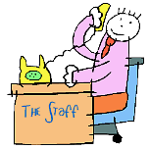

Word 1: Word 2:

Word 3: Word 4:

Colours/Shapes:



...ct

Copy the words again

**-ct, -ft, -lb, -lt, -mp, -nd, -ng, -nk, -nt, -pt, -sk, -sp, -st**



sometimes

many

gone

doing

world

world

sometimes

many

gone

doing

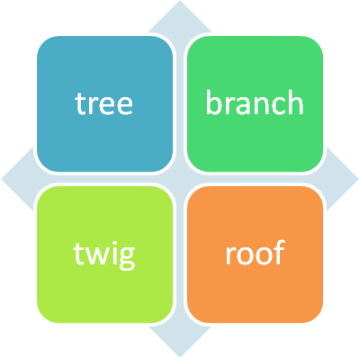

1. Write down which one you think is the odd one out. Remember to say why you think it is the odd one out (justify). 2. Put each word into a sentence.

Sign/type

Your name: