**A few other notes that may be of use.**

-‘Online Version’ means that the worksheet is done solely on the computer using Microsoft WORD programme.

-Except for the listed words and sentences, the main point is for the child to get used to the actual list words rather than it being about getting all the spelling correct (depending on their ability).

-For the ‘Printable Version’ of the unit, it may also be an idea to enlarge the sheets from A4 to A3 to give the child (especially the younger/less able children) more room to write.

-A blank copy of the worksheet (Teacher Created A1 and A2) has also been attached for the teacher to write in/type in their own ideas/letters/words/images etc.

-A copy of the words from the ‘Essential List 1 and 2’ spelling words has also been included in this resource. These have been included in lighter text so the child can trace over them. All the actual spelling words used in this resource include all of the words from Essential Lists 1 and 2.

Please feel free to use this resource in any way that you see fit with the child/person you are using it with. It is about increasing their confidence, spelling skills and literacy skills. How you do it is up to you. I hope that you find it useful.



**Section 1 – Me, Me, Me, Me**

Children simply fill out all the sections about their personal life. The whole point of this is to get the children familiar in recognising and writing common words/things to do with them so they are familiar with them. Repetition of this section remains the same on all worksheets (except for the ‘something else about me’, where they can write anything else about themselves, such as hair colour, likes, tv programmes, dislikes etc).

**Section 2 – Visual Language/Images**

Children write down what the photo/image shows. Then they write 4 different words about anything to do with the image. They then try to write one or more colours and/or shapes that they can see in the image.

**Section 3 – Handwriting/Letters/Blends**

Children handwrite (or type if doing this on computer) a line based on the lower case, then upper case of the letter shown (just like normal handwriting). Upper (capital) and Lower (small letters) letters are both focussed on. They then do the same based on the blend shown. Then they try to write down three words based on each letter and blend shown.

**Section 4 – Similar Sounds/Endings/Trace the Letters**

Children try to write three words that have the shown letters/parts of a word shown. E.g; ‘ _an’ could be ‘fan, can, pan’. Then they copy the words again in the blue boxes. The letters at the bottom of the page are for the child to trace over. If this is being done as an ‘Online’ worksheet, then the child could do each one different colours on the computer (as they will be unable to physically write on the sheet).

**Section 5 – List 1 and 2 (actual Spelling) Words-Word Study**

Each colour is related (so for example, all the green boxes are related to the word in the first green box). Each word/sentence has three boxes. The first has the list word written in black. The second box has the same word but done with a lighter colour for the child to trace over. The third box is empty for the child to write/copy the word into that box.

**Section 6 – Mixed Up Sentences**

These boxes are also done using colours and are related to the spelling (list) words originally used in Section 5. The child tries to unscramble the sentence so that it makes sense and is the same as the original sentence in the same coloured box in section 5. The capital letter for the start of the sentence and the full stop at the end of the sentence has also been included for the child to get use to those concepts.

**Section 7 – Odd One Out**

Three of the four words are related and one does not belong. The child says which one is the odd one out and why (there is also a space for the child to also list the colour of the box that the odd word out is in). Depending on the ability of the child, this maybe done orally only and/or may simply be where the child copies the word.

**Signature**

The child writes in their name in the space in the bottom right hand corner.

Name: School:



Class: Year: Age: Day:

Date: Teacher:

Parent name/s:

My Address:

My Phone Number: My Town/City/Area:

My Friends:

Something else about me:

What is it?

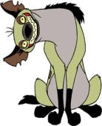

Word 1: Word 2:

Word 3: Word 4:

Colours/Shapes:



**words**

**words**



Copy the words again

**A-B-C-D-E-F-G-H-I-J-K-L-M-N-O-P-Q-R-S-T-U-V-W-X-Y-Z**



Read the sentence with the teacher, circle the word used, trace the word, then copy the word into the last box.

A word to do with you (like your name, address etc).

Colour used:



Sign/type

Your name:

Write down which one you think is the odd one out. Remember to say why and what colour box it is in.

Aa Bb Cc Dd



Ee Ff Gg Hh

Ii Jj Kk Ll

Mm Nn Oo Pp

Qq Rr Ss Tt

Uu Vv Ww Xx

Yy Zz



a I it the was and in

my to

we



at had of that

up but he on

then went for

is she there

when got me

so they you

Name: School:



Class: Year: Age: Day:

Date: Teacher:

Parent name/s:

My Address:

My Phone Number: My Town/City/Area:

My Friends:

Something else about me:

What is it?

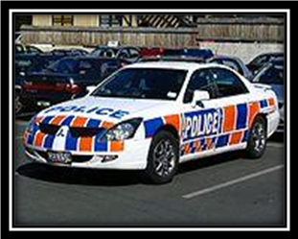

Word 1: Word 2:

Word 3: Word 4:

Colours/Shapes:

**a**



**A**

**bl**

**Aa words**

**Bl words**

_ a t



Copy the words again

**A-B-C-D-E-F-G-H-I-J-K-L-M-N-O-P-Q-R-S-T-U-V-W-X-Y-Z**



in

I

and

a

the

the

in

I

and

a

Read the sentence with the teacher, circle the word used, trace the word, then copy the word into the last box.

You and me.

I am working.

That is a cat.

That is a cat.

You and me.

I am working.

A word to do with you (like your name, address etc).

The cat is in the hat.

The cat is fluffy.

The cat is fluffy.

The cat is in the hat.

Colour used:

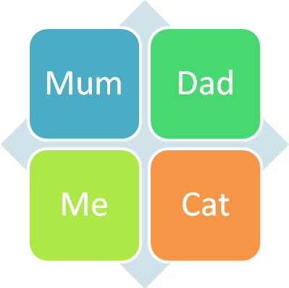

The is cat fluffy.

cat in hat. the The is

am working. I

and me. You

cat. is That a

Sign/type

Your name:

Write down which one you think is the odd one out. Remember to say why and what colour box it is in.

Name: School:



Class: Year: Age: Day:

Date: Teacher:

Parent name/s:

My Address:

My Phone Number: My Town/City/Area:

My Friends:

Something else about me:

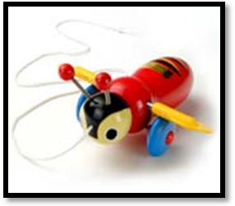

What is it?



Word 1: Word 2:

Word 3: Word 4:

Colours/Shapes:

**b**



**B**

**fl**

**Bb words**

**fl words**

_ a n



Copy the words again

**A-B-C-D-E-F-G-H-I-J-K-L-M-N-O-P-Q-R-S-T-U-V-W-X-Y-Z**



was

to

my

in

we

we

was

to

my

in

Read the sentence with the teacher, circle the word used, trace the word, then copy the word into the last box.

That is my cat.

I went to lunch.

The cat is in the hat.

The cat is in the hat.

That is my cat.

I went to lunch.

A word to do with you (like your name, address etc).

It was hot.

We are hot.

We are hot.

It was hot.

Colour used:

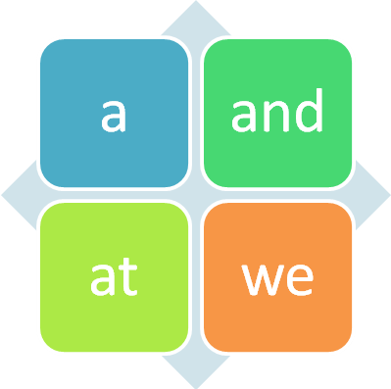

We hot. are

hot. was It

lunch. to went I

cat. my is That

cat in hat. the The is

Sign/type

Your name:

Write down which one you think is the odd one out. Remember to say why and what colour box it is in.

Name: School:



Class: Year: Age: Day:

Date: Teacher:

Parent name/s:

My Address:

My Phone Number: My Town/City/Area:

My Friends:

Something else about me:

What is it?

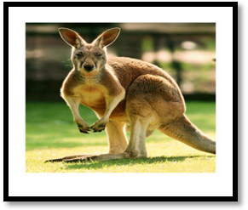

Word 1: Word 2:

Word 3: Word 4:

Colours/Shapes:

**c**



**C**

**dr**

**Cc words**

**dr words**

_ i t



Copy the words again

**A-B-C-D-E-F-G-H-I-J-K-L-M-N-O-P-Q-R-S-T-U-V-W-X-Y-Z**



that

of

had

at

up

up

that

of

had

at

Read the sentence with the teacher, circle the word used, trace the word, then copy the word into the last box.

I’ve had lunch.

It was because of the sun that I was hot.

I am at school.

I am at school.

I’ve had lunch.

because of the sun

A word to do with you (like your name, address etc).

That is a cat.

That is a cat.

The cat was up the tree.

The cat was up the tree.

Colour used:

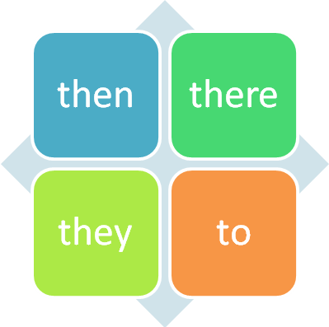

tree. the up was cat The

a is cat. That

sun of the because

lunch. had I’ve

I at am school.

Sign/type

Your name:

Write down which one you think is the odd one out. Remember to say why and what colour box it is in.

Name: School:



Class: Year: Age: Day:

Date: Teacher:

Parent name/s:

My Address:

My Phone Number: My Town/City/Area:

My Friends:

Something else about me:

What is it?

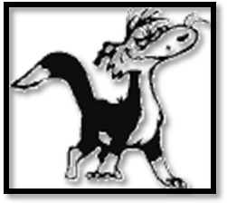

Word 1: Word 2:

Word 3: Word 4:

Colours/Shapes:

**d**



**D**

**br**

**Dd words**

**br words**

_ o t



Copy the words again

**A-B-C-D-E-F-G-H-I-J-K-L-M-N-O-P-Q-R-S-T-U-V-W-X-Y-Z**



then

on

he

but

went

went

then

on

he

but

Read the sentence with the teacher, circle the word used, trace the word, then copy the word into the last box.

He is a boy.

I turned the TV on.

But it is hot.

But it is hot.

He is a boy.

I turned the TV on.

A word to do with you (like your name, address etc).

Then we had tea.

We went home.

We went home.

Then we had tea.

Colour used:

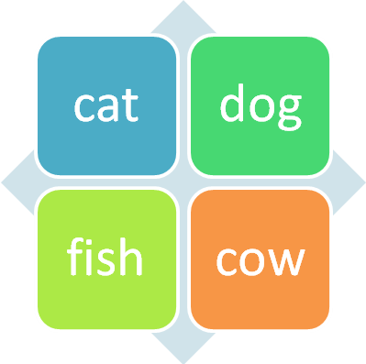

home. went We

tea. had Then we

on. TV the turned I

He a is boy.

hot. is it But

Sign/type

Your name:

Write down which one you think is the odd one out. Remember to say why and what colour box it is in.

Name: School:



Class: Year: Age: Day:

Date: Teacher:

Parent name/s:

My Address:

My Phone Number: My Town/City/Area:

My Friends:

Something else about me:

What is it?

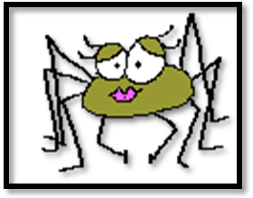

Word 1: Word 2:

Word 3: Word 4:

Colours/Shapes:

**e**



**E**

**gl**

**Ee words**

**gl words**

_ u t



Copy the words again

**A-B-C-D-E-F-G-H-I-J-K-L-M-N-O-P-Q-R-S-T-U-V-W-X-Y-Z**



there

she

is

for

when

when

there

she

is

for

Read the sentence with the teacher, circle the word used, trace the word, then copy the word into the last box.

That is a cat.

She is a girl.

We went for a walk.

We went for a walk.

That is a cat.

She is a girl.

A word to do with you (like your name, address etc).

There is a cat.

When do we go?

When do we go?

There is a cat.

Colour used:

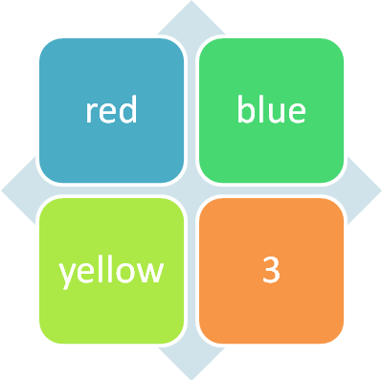

go? we do When

cat. a is There

She girl. a is

cat. a is That

We went a walk. for

Sign/type

Your name:

Write down which one you think is the odd one out. Remember to say why and what colour box it is in.

Name: School:



Class: Year: Age: Day:

Date: Teacher:

Parent name/s:

My Address:

My Phone Number: My Town/City/Area:

My Friends:

Something else about me:

What is it?



Word 1: Word 2:

Word 3: Word 4:

Colours/Shapes:

**f**



**F**

**pl**

**Ff words**

**pl words**

_ a d



Copy the words again

**A-B-C-D-E-F-G-H-I-J-K-L-M-N-O-P-Q-R-S-T-U-V-W-X-Y-Z**



they

so

me

got

you

you

they

so

me

got

Read the sentence with the teacher, circle the word used, trace the word, then copy the word into the last box.

It was me.

So are you hungry?

He got a lolly.

He got a lolly.

It was me.

So are you hungry?

A word to do with you (like your name, address etc).

They are cold.

Are you happy?

Are you happy?

They are cold.

Colour used:

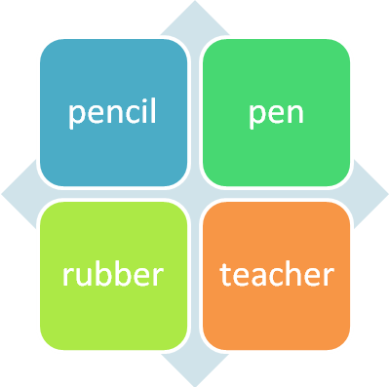

happy? Are you

cold. They are

hungry? you So are

It me. was

He a lolly. got

Sign/type

Your name:

Write down which one you think is the odd one out. Remember to say why and what colour box it is in.