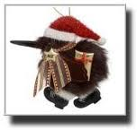
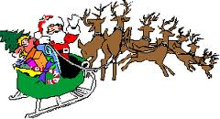

Name

School

Class

Contract Number
Date Started
Date Completed
Self Assessment Grade/Mark
Ongoing Self Assessment Comment/Notes
1

2

3

4

5

6

7

8

9

10

My Other Notes or Comments

Name

School

Class

This “Student Task Sheet” is for you to use where there is no room on the actual contracts for you to write in your answers, and/or extra room for any extra tasks your teacher gives you. It is important that when you are using this sheet, that you list both the Contract Number as well as the Question/Answer Number. E.g: To answer Question 14 on Contract 1, you would write “Contract 1, Q 14” before writing in your answer. If in doubt, ask your teacher.

Name

School

Class

This “Student Task Sheet” is for you to use where there is no room on the actual contracts for you to write in your answers, and/or extra room for any extra tasks your teacher gives you. It is important that when you are using this sheet, that you list both the Contract Number as well as the Question/Answer Number. E.g: To answer Question 14 on Contract 1, you would write “Contract 1, Q 14” before writing in your answer. If in doubt, ask your teacher.

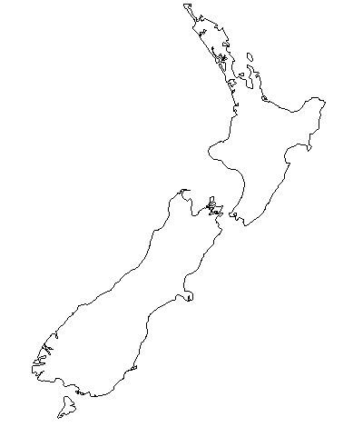

Name

School

Class
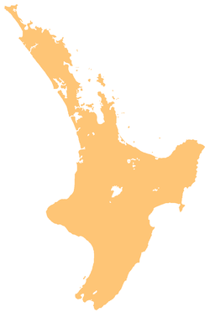
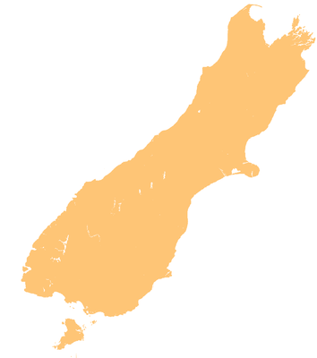
If using this page with the ‘Online Version’, you will need to do either of the following; (a) print this off for the children to do in hard copy, (b) get the children to make up their own map, (c) get the children to do their own map as an attachment using a separate Word document.

Name

School

Class

Teacher

Date

Year/Age

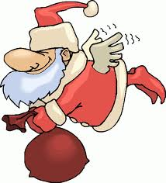

Write at least 5 words to do with Christmas that begin with the following letters:
Using the map, help show Santa where he needs to go.



1. North Island
Name one Christmas song that you know of. Do you also know who sings it?
Auckland
Write down what would be your dream Christmas dinner and/or pudding.
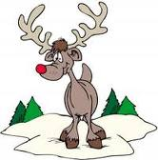
2. South Island

Christchurch

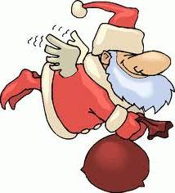
What is the mixed up word?
atnsa
What Am I?

Where Am I?
Write 5 words related to the picture.

3. Now show where in New Zealand you live

Now make up your own mixed up word (it has to be different from the one in E). Make sure you write the mixed up word and the answer.

Make up and complete one of your own activities related to Christmas. You may want to check with your teacher first. It must be one that you have not previously done in these contracts. Write what you chose to do?

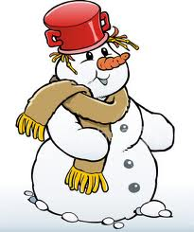
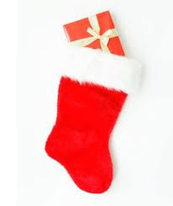


Using words from your writing, make up your own Christmas wordfind below.

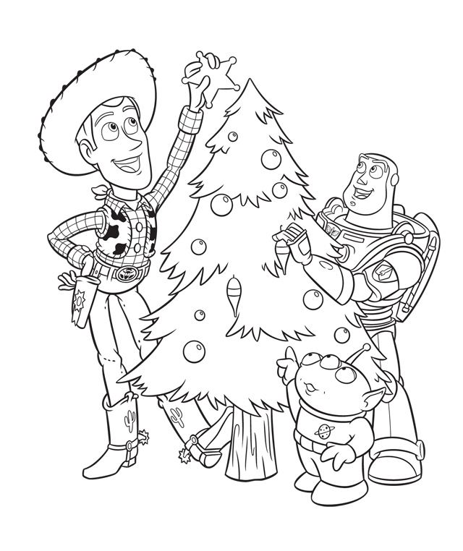

Name

School

Class

Teacher

Date

Year/Age

Write at least 5 words to do with Christmas that begin with the following letters:
Using the map, help show Santa where he needs to go.

1. North Island
Name one funny Christmas song that you know of (a different one). Do you also know who sings it?
Hamilton
Write down one or two things you could do for a friend who is lonely or sad during Christmas.
2. South Island

Dunedin

What is the mixed up word?
samtsirhC
What Am I?

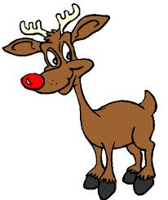
Where Am I?
Write 5 words related to the picture.

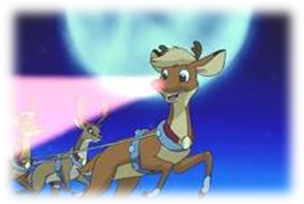

Now make up your own mixed up word (it has to be different from the one in E). Make sure you write the mixed up word and the answer.

Make up and complete one of your own activities related to Christmas. You may want to check with your teacher first. It must be one that you have not previously done in these contracts. Write what you chose to do?

Using words from your writing, make up your own Christmas wordfind below.

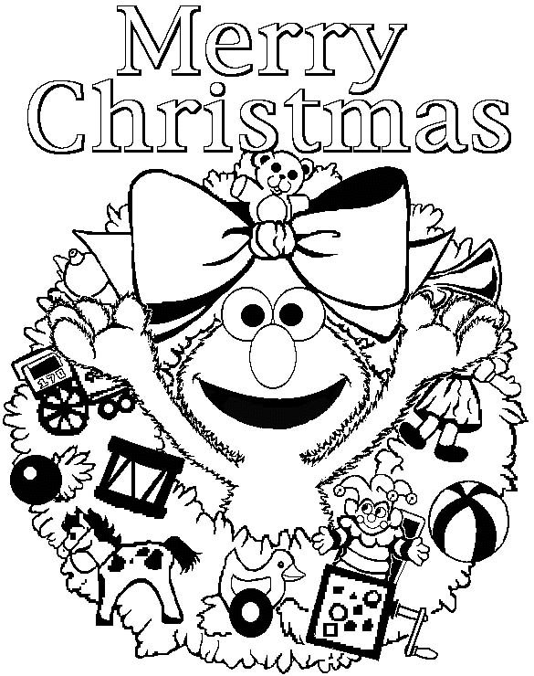

Name

School

Class

Teacher

Date

Year/Age

Write at least 5 words to do with Christmas that begin with the following letters:
Using the map, help show Santa where he needs to go.

1. North Island
Name one Christmas
TV programme you know of .
Wellington
If you had a free wish and could ask for anything you wanted from Santa, what would it be? Say why.
2. South Island

Invercargill

What is the mixed up word?
sydailoh
Who Am I?

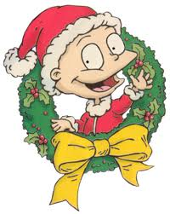
Where Am I?
Write 5 words related to the picture.

Now make up your own mixed up word (it has to be different from the one in E). Make sure you write the mixed up word and the answer.

Make up and complete one of your own activities related to Christmas. You may want to check with your teacher first. It must be one that you have not previously done in these contracts. Write what you chose to do?

Using words from your writing, make up your own Christmas wordfind below.

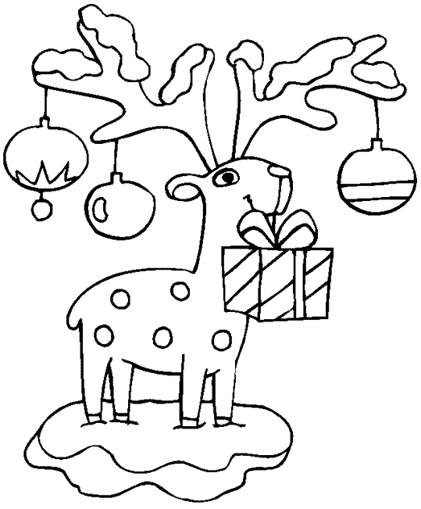

Name

School

Class

Teacher

Date

Year/Age

Write at least 5 words to do with Christmas that begin with the following letters:
Using the map, help show Santa where he needs to go.

1. North Island
Name one cartoon that has a
Christmas theme.
Gisborne
Write down at least 2 great things you have done this year where you have helped someone out.
2. South Island

Greymouth

What is the mixed up word?
failym
What Am I?

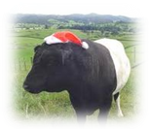
Where Am I?
Write 5 words related to the picture.

Now make up your own mixed up word (it has to be different from the one in E). Make sure you write the mixed up word and the answer.

Make up and complete one of your own activities related to Christmas. You may want to check with your teacher first. It must be one that you have not previously done in these contracts. Write what you chose to do?

Using words from your writing, make up your own Christmas wordfind below.

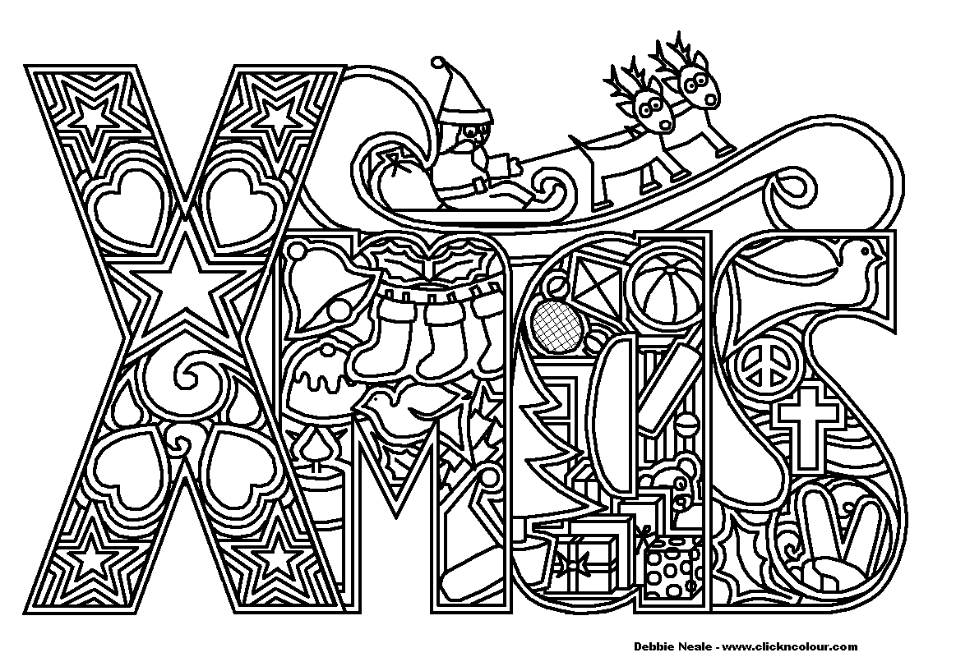

Name

School

Class

Teacher

Date

Year/Age

Write at least 5 words to do with Christmas that begin with the following letters:
Using the map, help show Santa where he needs to go.

1. North Island
Name one book that has a
Christmas theme.
Palmerston North
Write down at least two great things where someone has helped you out this year? (what did they do?)

2. South Island

Nelson

What is the mixed up word?
chclooeta
Who Are We?

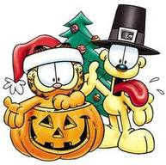
Where Am I?
Write 5 words related to the picture.

Now make up your own mixed up word (it has to be different from the one in E). Make sure you write the mixed up word and the answer.

Make up and complete one of your own activities related to Christmas. You may want to check with your teacher first. It must be one that you have not previously done in these contracts. Write what you chose to do?

Using words from your writing, make up your own Christmas wordfind below.

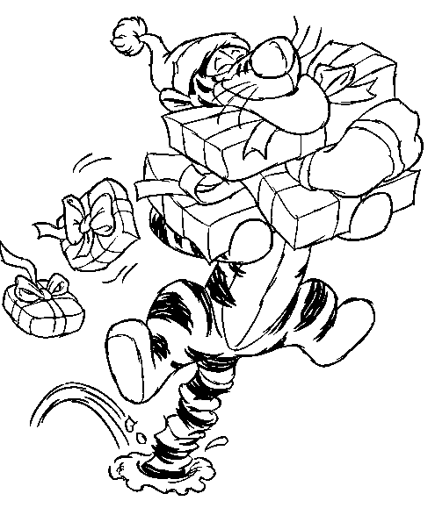

Name

School

Class

Teacher

Date

Year/Age

Write at least 5 words to do with Christmas that begin with the following letters:
Using the map, help show Santa where he needs to go.

1. North Island
Name one Christmas song that you know of. Do you also know who sings it?
New Plymouth
If you had another free wish and could ask for anything you wanted from Santa, what would it be? Say why.

2. South Island

Picton

What is the mixed up word?
psrtnese
Who Am I?

Where Am I?
Write 5 words related to the picture.

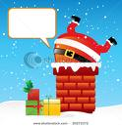

Now make up your own mixed up word (it has to be different from the one in E). Make sure you write the mixed up word and the answer.

Make up and complete one of your own activities related to Christmas. You may want to check with your teacher first. It must be one that you have not previously done in these contracts. Write what you chose to do?

Using words from your writing, make up your own Christmas wordfind below.

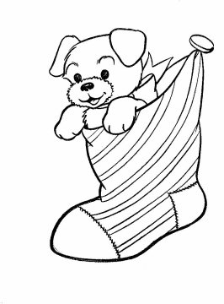

Name

School

Class

Teacher

Date

Year/Age

Write at least 5 words to do with Christmas that begin with the following letters:
Using the map, help show Santa where he needs to go.

1. North Island
Name one TV programme that
has a Christmas theme?
Whanganui
Santa has asked you to feed Rudolph for dinner. What are you going to give him?
2. South Island

Kaikoura

What is the mixed up word?
Drebmeec
What Am I?


Where Am I?
Write 5 words related to the picture.

Now make up your own mixed up word (it has to be different from the one in E). Make sure you write the mixed up word and the answer.

Make up and complete one of your own activities related to Christmas. You may want to check with your teacher first. It must be one that you have not previously done in these contracts. Write what you chose to do?

Using words from your writing, make up your own Christmas wordfind below.

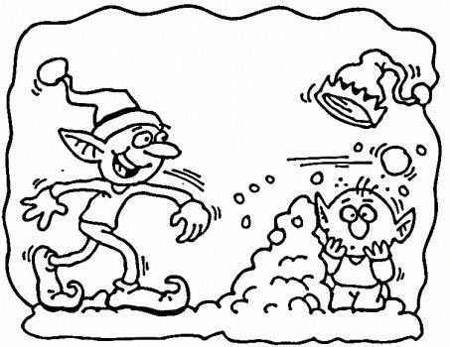

Name

School

Class

Teacher

Date

Year/Age

Write at least 5 words to do with Christmas that begin with the following letters:
Using the map, help show Santa where he needs to go.

1. North Island
Name one cartoon that has a
Christmas theme?
Taupo
Because you don’t have a chimney, you have told Santa you will make a secret door for him. Where will it be?
2. South Island

Hokitika

What is the mixed up word?
hplodRu
Who Am I?

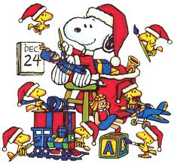
Where Am I?
Write 5 words related to the picture.

Now make up your own mixed up word (it has to be different from the one in E). Make sure you write the mixed up word and the answer.

Make up and complete one of your own activities related to Christmas. You may want to check with your teacher first. It must be one that you have not previously done in these contracts. Write what you chose to do?

Using words from your writing, make up your own Christmas wordfind below.

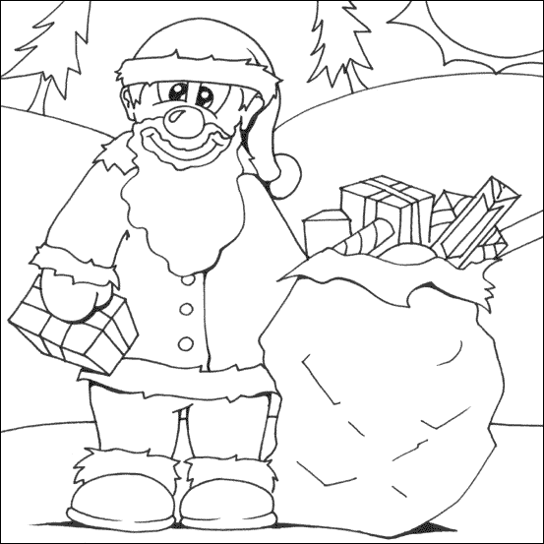

Name

School

Class

Teacher

Date

Year/Age

Write at least 5 words to do with Christmas that begin with the following letters:
Using the map, help show Santa where he needs to go.

1. North Island
Name one funny Christmas song that you know of. Do you also know who sings it?
Napier
Santa has asked you to make up a secret saying for him to get into your secret door. What is the secret saying?
2. South Island

Westport

What is the mixed up word?
frsdnei
What is this?

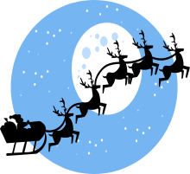
Where Am I?
Write 5 words related to the picture.

Now make up your own mixed up word (it has to be different from the one in E). Make sure you write the mixed up word and the answer.

Make up and complete one of your own activities related to Christmas. You may want to check with your teacher first. It must be one that you have not previously done in these contracts. Write what you chose to do?

Using words from your writing, make up your own Christmas wordfind below.

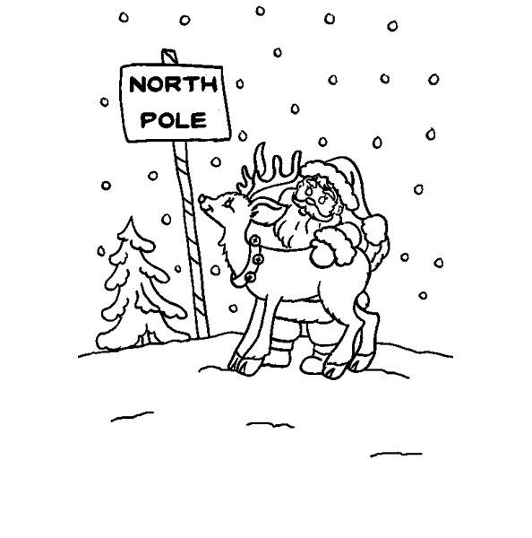

Name

School

Class

Teacher

Date

Year/Age

Write at least 5 words to do with Christmas that begin with the following letters:
Using the map, help show Santa where he needs to go.

1. North Island
Name one book that has a
Christmas theme.
Cape Reinga
Mrs Claus has asked you to send her a text to say what is taking Santa so long to get home. What do you say?
2. South Island

Bluff

What is the mixed up word?
xmihcney
What Am I?

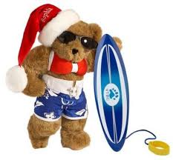
Where Am I?
Write 5 words related to the picture.

Now make up your own mixed up word (it has to be different from the one in E). Make sure you write the mixed up word and the answer.

Make up and complete one of your own activities related to Christmas. You may want to check with your teacher first. It must be one that you have not previously done in these contracts. Write what you chose to do?

Using words from your writing, make up your own Christmas wordfind below.



