National Standards: Year 3 NZ Curriculum: Level 2 |  | 2 | 0 | 1 | 0
Term (1 Year Cycle) |  | T1 | T2 | T3 | T4
Mathematics  Number and Algebra Standards | In contexts that require them to solve problems or model situations, students will be able to:
 | apply basic addition facts and knowledge of place value and symmetry to combine or partition whole numbers
 | apply basic addition facts and knowledge of place value and symmetry to find fractions of sets, shapes, and quantities;
 | create and continue sequential patterns with one or two variables by identifying the unit of repeat;
 | continue spatial patterns and number patterns based on simple addition or subtraction.
Mathematics  Geometry and Measurement Standards | In contexts that require them to solve problems or model situations, students will be able to:
 | measure the lengths, areas, volumes or capacities, and weights of objects and the duration of events, using linear whole-number scales and applying basic addition facts to standard units;
sort objects and two- and three-dimensional shapes by their features, identifying categories
within categories;
 | represent reflections, translations, and rotations by creating and describing patterns;
 | describe personal locations and give directions, using whole-number measures and half- or quarter-turns.
Mathematics  Statistics Standards | In contexts that require them to solve problems or model situations, students will be able to:
 | investigate questions by using the statistical enquiry cycle (with support) to gather and display category and simple whole-number data
 | investigate questions by using the statistical enquiry cycle (with support) to interpret displays in context;
 | compare and explain the likelihoods of outcomes for a simple situation involving chance.
English  Reading  Standards | After three years at school, students will read, respond to, and think critically about fiction and non-fiction texts at the Gold level of Ready to Read (the core instructional series that supports reading in the New Zealand Curriculum).  Key charachteristics of texts at Gold level:  Texts at Gold level have been designed with characteristcs that include:
 | • some unfamiliar contexts and settings;
 | • shifts in time and/or place;
 | • (in narrative texts) many characters and events and more than one storyline;
 | • a mix of explicit and implicit content within text and illustrations that requires students to make connections between ideas in the text and their prior knowledge in order to make simple inferences;
 | • some pages with no illustrations;
 | • some unfamiliar words and phrases, the meaning of which is supported by the context or illustrations, including descriptive vocabulary, subject-specific vocabulary, and commonly used words that have multiple meanings;
 | • visual language features such as subheadings, text boxes, footnotes, glossaries, indexes, and diagrams and maps that are clearly explained and linked to the body text;
 | • ideas and information organised in paragraphs;
 | • a variety of sentence structures, including complex sentences;
 | • frequent use of dialogue, some of which is not explicitly attributed, and more than one character speaking on a page.
National Standards: Year 3 NZ Curriculum: Level 2 |  | 2 | 0 | 1 | 0
Term (1 Year Cycle) |  | T1 | T2 | T3 | T4
English  Writing  Standards | After three years at school, students will create texts in order to meet the writing demands of the New zealand Curriculum as they work towards level 2. Students will use their writing to think about, record, and communicate experiences, ideas, and information to meet specific learning purposes across the curriculum.  Key charachteristics of texts that students read at this level are as follows:  Students will write for a range of different purposes linked to the curriculum, using a process and drawing on the knowledge, skills, and attitudes that will help them achieve their purpose. The knowledge, skills, and attitudes expected  at this level, including those needed for spelling and punctuation, are described in the Literacy Learning Progressions.  Students will independently write texts that are clearly directed to a particular audience. They will organise their texts according to a basic structure that meets their purpose for writing (for example, a story with a beginning, a middle, and an end). These texts will include, when appropriate:
 | • content, mostly relevant, that conveys several experiences, items of information, and/or ideas relating to a curriculum topic and that sometimes includes detail and/or comment;
 | • mainly simple and compound sentences that vary in their beginnings and lengths and in the simple conjunctions used;
 | • attempts at some complex sentences;
 | • some specific vocabulary that is appropriate to the content of the text.

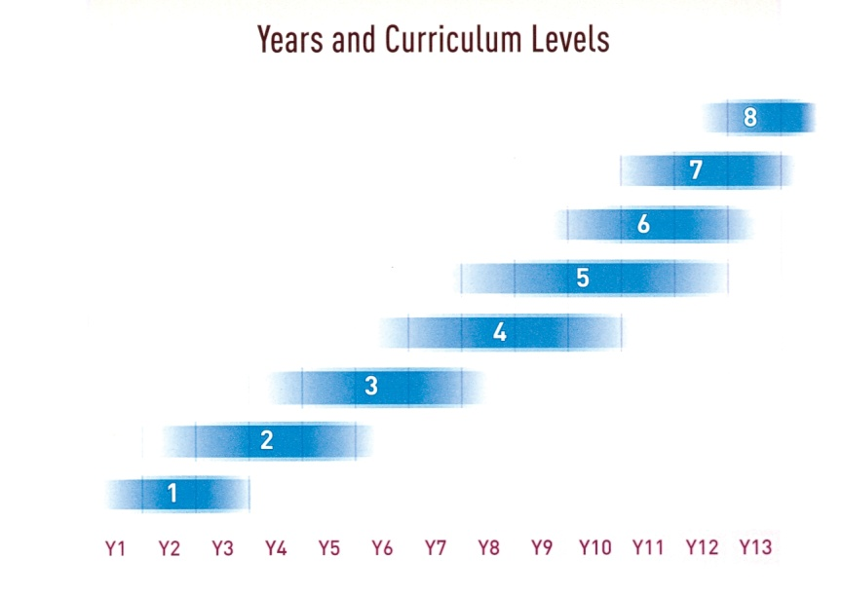
Year
8
Year
5
Year
4
Year
3
Year
2
Year
1
Year
7
Year
6

Well Below Standard (WBS) | Below Standard (BS) | At Standard (ATS) | Above Standard (ABS)
B: G:  M: E: O: | B: G:  M: E: O: | B: G:  M: E: O: | B: G:  M: E: O:
Years 0/1 & 2 = L.1 Years 3 & 4 = L.2 Years 5 & 6 = L.3 Years 7 & 8 = L.4
Assessment Trends: B = Boys, G = Girls, M = Māori , E = European, O = Other
Notes:

