National Standards: Year 8 NZ Curriculum: Level 4 |  | 2 | 0 | 1 | 0
Term (1 Year Cycle) |  | T1 | T2 | T3 | T4
Mathematics  Number and Algebra Standards | In contexts that require them to solve problems or model situations, students will be able to:
 | apply multiplicative strategies flexibly to whole numbers, ratios, and equivalent fractions (including decimals and percentages);
 | use multiplication and division as inverse operations on whole numbers;
 | apply additive strategies flexibly to decimals and integers;
 | find and represent relationships in spatial and number patterns, using: tables and graphs, equations for linear relationships, recursive rules for non-linear relationships;
 | apply inverse operations to simple linear relationships.
Mathematics  Geometry and Measurement Standards | In contexts that require them to solve problems or model situations, students will be able to:
 | use metric and other standard measures;
 | make simple conversions between units, using decimals;
 | use side or edge lengths to find the perimeters and areas of rectangles, parallelograms, and triangles and the volumes of cuboids;
 | sort two- and three-dimensional shapes into classes, considering the relationships between the classes and justifying the decisions made;
 | identify and describe the features of shapes or patterns that change or do not change under transformation;
 | create or identify nets for rectangular prisms and other simple solids, given particular requirements;
 | draw or make objects, given their plan, front, and side views or their perspective views;
 | describe locations and give directions, using scales, bearings, and co-ordinates.
Mathematics  Statistics Standards | In contexts that require them to solve problems or model situations, students will be able to:
 | investigate summary, comparison, and relationship questions by using the statistical enquiry cycle:
 | gather or access multivariate category, measurement, and time-series data ,
 | sort data and display it in multiple ways, identifying patterns, variations, relationships, and trends and using ideas about middle and spread where appropriate
 | interpret results in context, identifying factors that produce uncertainty;
 | express as fractions the likelihoods of outcomes for situations involving chance, checking for consistency between experimental results and models of all possible outcomes.
English  Reading  Standards | By the end of year 8, students will read, respond to, and think critically about texts in order to meet the reading demands of the New Zealand Curriculum at level 4. Students will locate, evaluate, and synthesise information and ideas within and across a range of texts appropriate to this level as they generate and answer questions to meet specific learning purposes across the curriculum.* (* The text and task demands of the curriculum are similar for students in year 7 and year 8. The difference in the standard for year 8 is the students’ increased accuracy and speed in reading a variety of texts from across the curriculum, their level of control and independence in selecting strategies for using texts to support their learning, and the range of texts they engage with. In particular, by the end of year 8, students need to be confidently  and deliberately choosing the most appropriate strategies for reading in different learning areas.)  Key charachteristics of texts that students read at this level are as follows:  The texts that students use to meet the reading demands of the curriculum at this level will often include:
• elements that require interpretation, such as complex plots, sophisticated themes,
and abstract ideas;
• complex layers of meaning, and/or information that is irrelevant to the identified
purpose for reading (that is, competing information), requiring students to
infer meanings or make judgments;
 | • non-continuous text structures and mixed text types;
• sentences that vary in length, including long, complex sentences that contain a lot
of information;
 | • adverbial clauses or connectives that require students to make links across the whole text;
 | • academic and content-specific vocabulary;
• words and phrases with multiple meanings that require students to know and use
effective word-solving strategies to retain their focus on meaning;
National Standards: Year 8 NZ Curriculum: Level 4 |  | 2 | 0 | 1 | 0
Term (1 Year Cycle) |  | T1 | T2 | T3 | T4
English  Reading  Standards | • metaphor, analogy, and connotative language that is open to interpretation;
• illustrations, photographs, text boxes, diagrams, maps, charts, and graphs,
containing main ideas that relate to the text’s content;
Such texts will include both fiction and non-fiction in electronic and print media.
They may be published individually (for example, as novels, reference materials,
textbooks, or modified scientific and historical texts) or in collections (for example,
age-appropriate newspapers, magazines, and journals, including the School Journal).
Poetry, plays, procedural texts, and extended instructions (for example, in science and
mathematics) often appear in collections or textbooks.
English  Writing  Standards | By the end of year 8, students will create texts in order to meet the writing demands of the New Zealand Curriculum at level 4. Students will use their writing to think about, record, and communicate experiences, ideas, and information to meet  specific learning purposes across the curriculum.* * (The text and task demands of the curriculum are similar for students in year 7 and year 8. The difference in the standard for year 8 is the students’ increased accuracy and fluency in writing a variety of texts across the curriculum, their level of control and independence in selecting writing processes and strategies, and the range of texts they write. In particular, by the end of year 8, students need to be confidently and deliberately choosing the most appropriate processes and strategies for writing in different learning areas.)  Key charachteristics of texts that students read at this level are as follows:
 | Students will write for a range of different purposes on topics and themes across the curriculum at this level, selecting and applying a process appropriate to the task and drawing on the knowledge, skills, and attitudes that will help them achieve their purpose. The knowledge, skills, and attitudes expected at this level, including those needed for spelling and punctuation, are described in the Literacy Learning Progressions.
 | Students will independently write texts, choosing language and a clear and logical text structure that they have deliberately chosen for their specific audience and purpose, drawing on their knowledge of the conventions for particular text forms (for example, when writing personal narratives, poems, arguments, feature articles, character profiles, research reports, essays, responses to literature, and short answers). These texts will include, when appropriate...
 | • content that is concise and relevant to the curriculum task and that often includes detail and/or comment supporting or elaborating on the main points;
 | • paragraphs within which the ideas are clearly related and links within and between paragraphs;
 | • grammatically correct sentences;
 | • words and phrases that are appropriate to the topic, register, and purpose, including expressive, academic, and subject-specific vocabulary.
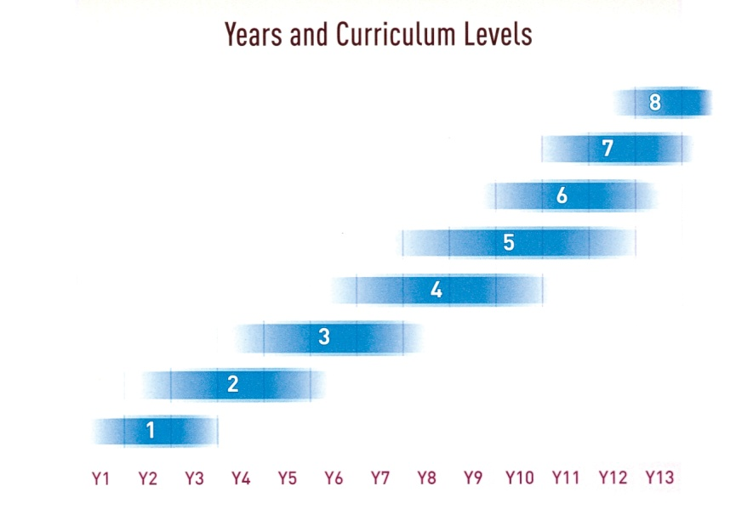
Year
5
Year
4
Year
3
Year
2
Year
1
Year
8
Year
7
Year
6

Well Below Standard (WBS) | Below Standard (BS) | At Standard (ATS) | Above Standard (ABS)
B: G:  M: E: O: | B: G:  M: E: O: | B: G:  M: E: O: | B: G:  M: E: O:
Years 0/1 & 2 = L.1 Years 3 & 4 = L.2 Years 5 & 6 = L.3 Years 7 & 8 = L.4
Assessment Trends: B = Boys, G = Girls, M = Māori , E = European, O = Other

