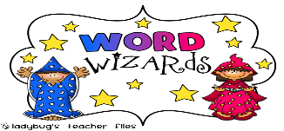
Your School, Room: – Years:
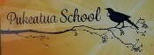
Word Study Tasks - Sheet 2
 | 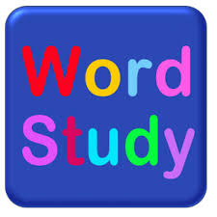  Monday | Tuesday | Wednesday | Thursday | Friday
Blends
(5 blend words).

 | gl | dr | fr
Words  (5 words related to the word). | Sea | Furniture | Books
Word Images  Draw 5 mini pictures related to the word. | Dragons | Blends | Octopus
Punctuation/Grammar
Write one sentence using the punctuation.

 | ,  (comma) | Use of 2 capital letters | ?
Make the sentence more descriptive. | The kiwi blinked. | The boy drew his sword. | The girl showed her pilots licence.
Homonyms/ Homophones (words that sound the same).  Write both meanings. | Dear  Deer | Banned  Band | Bear  Bare
Similes (comparisons)  What does this mean/what is the message? | As brave as a lion. | As busy as a bee. | As clear as crystal.
 | Monday | Tuesday | Wednesday | Thursday | Friday
Anagrams  (change the letters to make a new word). | Edit (2)  The new word starts with the underlined word. | Softer | Horse
Contractions  (shorten the word). | They are | We are | We were
Compound Words  (make 2 words into 1).  Some+thing=something | Write your own
Antonyms  (x3 opposites) | Fast | Sleep | Vertical
Suffix
(ends of words).
Make a new word.
 | ies | y | ly
Prefix
(beginning of words).
Make a new word.
 | tend | allowed | come
Proverbs  (sayings)  What does this mean? | A rolling stone gathers no moss | A fool and his money are soon parted. | A hungry man is an angry man.
Plurals  (two or more)  Change the word. | Spider | Teddy | Chair
Singular  (just one)  Change the word. | Sheep | Ants | Tables
Synonyms  (similar meanings).  X3 words that have similar meanings. | Happy | Work | Aquatics

