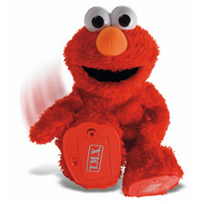
Reading (T3, 2018).
What to do A.

Choose an item from one of the Journals. Read it to yourself or with another person in your group, then do the following activities listed on the board based on it. Make sure your write the question number beside your answers.

1. Title
2. School Journal Part Number and Year (it’s on the front)
3. X3 text Q and A’s
4. X3 picture Q and A’s
5. Author/illustrator
6. X1 Q and A based on the Contents page.
7. Synopsis (what was it about?)
8. Your Opinion (what you thought)
9. Illustration (picture) and or diagram.
10. Who and what age would you recommend it to, and why?
11. What is the genre?
12. Choose 5 words that start with the letter ? (ask me what letter)
13. Choose at least 5 blend words
14. Write down at least 5 words which are hard/factual/informative, and write a meaning for them.
15. Other (I will tell you what this is when I want you to do it).

