Numbers (Version 2)
Time taken to answer:___________
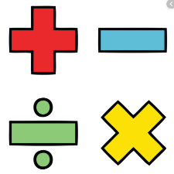
1. Roll the dice 2 times and write each number in each box
=

-----------------------------------------------------------------------------------------------------------------------
Time taken to answer:___________
2. Roll the dice 2 times and write each number in each box
=

-----------------------------------------------------------------------------------------------------------------------
Time taken to answer:___________
3. Roll the dice 2 times and write each number in each box
=

-----------------------------------------------------------------------------------------------------------------------
Time taken to answer:___________
4. Roll the dice 2 times and write each number in each box
=

Numbers (addition using 3 digits) Version 2
Time:
1. Roll the dice 3 times and write each number in each box
=

Numbers I could get/working space

Time:
2. Roll the dice 3 times and write each number in each box
=

Numbers I could get/working space

Time:
3. Roll the dice 3 times and write each number in each box
=

Numbers I could get/working space

