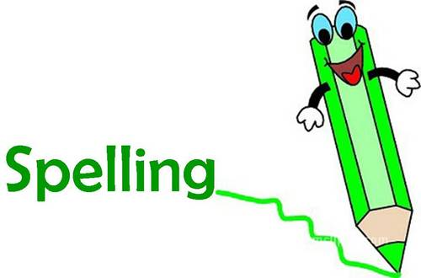
Spelling Words Activities

Monday: 1. New words for this week
2. Buddy test and mark these in your notebook
3. Alphabetical order

Tuesday: 1. Buddy test and mark these in your notebook
2. Syllables
3. Pages in the dictionary that your
words are located on

Wednesday: 1. Buddy test and mark these in your notebook
2. Synonyms and Antonyms of each word

Thursday: 1. Buddy test and mark these in your notebook
2. Sentences (remember capitals, sense etc)

Friday: 1. Buddy test and mark these in your notebook
2. Mark correct words off your list
3. Carry over incorrect words to next
weeks words in your notebook

