Swimming Pool Tests (using solution bottles and tablet) Term 1 - 2023
Pool Size: 54000 Litres  L = 12m W = 4.5m  Depth= 0.85cm & 1m | Monday | Tuesday | Wednesday | Thursday | Friday | 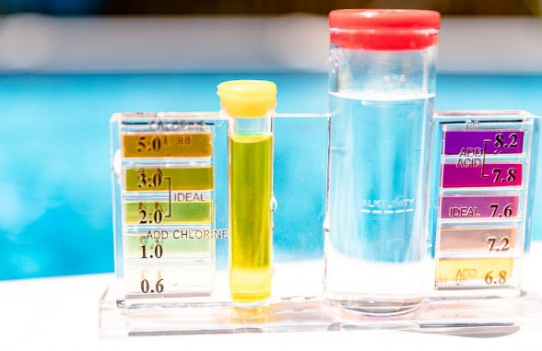  Saturday | Sunday
Chlorine Test
Left side of tube

Bromine Test

pH Test
Right side of tube

Acid Demand Test *use same water from pH test above.  * Count drops then refer to ‘Acid Demand Chart’. | Drops used:  Result: (based on 60k litres): | Drops used:  Result: (based on 60k litres): | Drops used:  Result: (based on 60k litres): | Drops used:  Result: (based on 60k litres): | Drops used:  Result: (based on 60k litres):
Total Alkalinity Test  (multiply the # of drops by 10)  We want to get to 120. | Drops used:  Result: | Drops used:  Result: | Drops used:  Result: | Drops used:  Result: | Drops used:  Result:
Water Temperature

Pump/ Filter Pressure 110 = Still on blue but just below red. Stable & consistent

Notes
When Vacuumed?

Swimming Pool Tests – (using AquaChek Strips – ‘Test & Treat’ (TT)’ or ‘AquaChek Smart’ (SM)- Term 1 - 2023
Pool Size: 54000 Litres  L = 12m W = 4.5m  Depth= 0.85cm & 1m | Monday | Tuesday | Wednesday | Thursday | Friday | 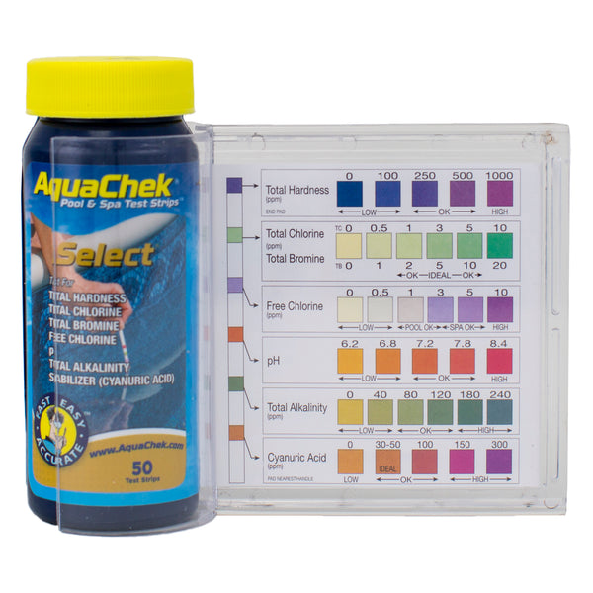  Saturday | Sunday
TT (Test & Treat)
or SM (Smart)
Test used?
Total Chlorine

Free Chlorine

pH Test

Total Alkalinity Test

Total Hardness
(not done with AquaChek Test & Treat)
Cyanuric Acid

Water Temperature

Pump/ Filter Pressure 110 = Still on blue but just below red. Stable & consistent

Pool Vacuumed Date

Notes

