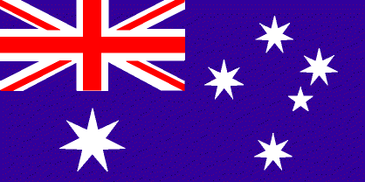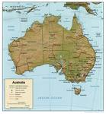

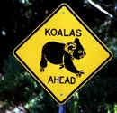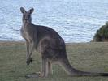C:\Users\Chris\AppData\Local\Microsoft\Windows\Temporary Internet Files\Content.IE5\H9WM8K7A\MCj03561130000[1].wmf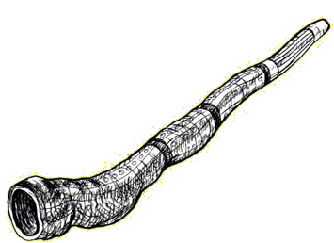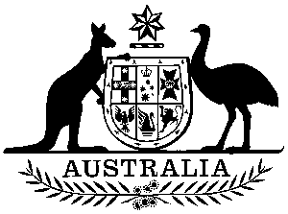

*A SOSE/English/Mathematics Unit*

1. Name of the Town/Place? ____________________________
2. Name of the Province/Area? __________________________
3. What State is it in? ________________________________
4. Closest Major City to the place?________________________
5. Special Features of the town/area? _____________________

___________________________________________________

1. Name of the next nearest town or city N-S-E-W of the place:

North South East West

____________ ____________ ____________ _____________

1. Library/Research Skills. Where in the library would you find literature if you wanted to find more out about the item in the picture, and/or the area? Think about the Dewey and other systems.

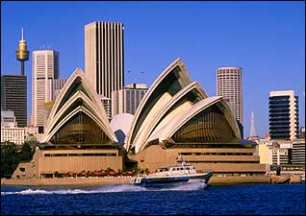

*8. Activity: Draw/illustrate/make up either of the following using icons of the area, and/or images of the town/area which give the place it’s local flavour/identity:*

A. Currency B. Flag C. A new icon D. A poster E. Your own idea



C:\Users\Chris\AppData\Local\Microsoft\Windows\Temporary Internet Files\Content.IE5\H9WM8K7A\MCj03561130000[1].wmf

*A SOSE/English/Mathematics Unit*

1. Name of the Town/Place? ____________________________
2. Name of the Province/Area? __________________________
3. What State is it in? ________________________________
4. Closest Major City to the place?________________________
5. Special Features of the town/area? _____________________

___________________________________________________

1. Name of the next nearest town or city N-S-E-W of the place:

North South East West

____________ ____________ ____________ _____________

1. Library/Research Skills. Where in the library would you find literature if you wanted to find more out about the item in the picture, and/or the area? Think about the Dewey and other systems.

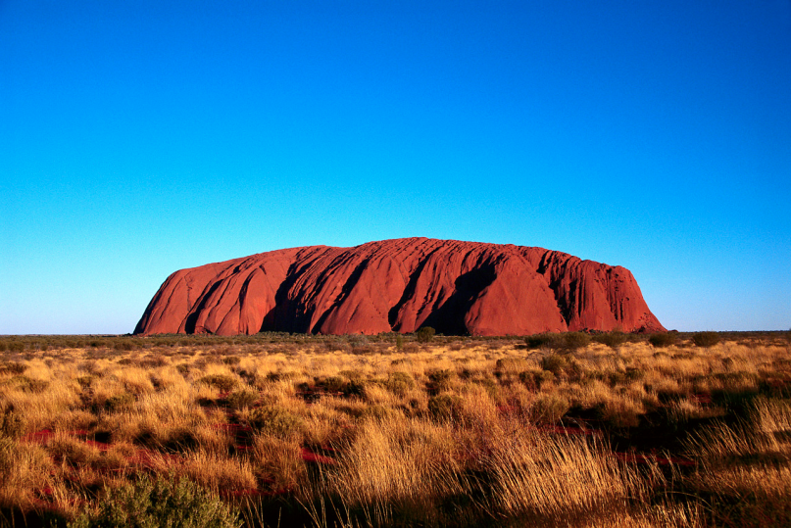

*8. Activity: Draw/illustrate/make up either of the following using icons of the area, and/or images of the town/area which give the place it’s local flavour/identity:*

A. Currency B. Flag C. A new icon D. A poster E. Your own idea



C:\Users\Chris\AppData\Local\Microsoft\Windows\Temporary Internet Files\Content.IE5\H9WM8K7A\MCj03561130000[1].wmf

*A SOSE/English/Mathematics Unit*

1. Name of the Town/Place? ____________________________
2. Name of the Province/Area? __________________________
3. What State is it in? ________________________________
4. Closest Major City to the place?________________________
5. Special Features of the town/area? _____________________

___________________________________________________

1. Name of the next nearest town or city N-S-E-W of the place:

North South East West

____________ ____________ ____________ _____________

1. Library/Research Skills. Where in the library would you find literature if you wanted to find more out about the item in the picture, and/or the area? Think about the Dewey and other systems.

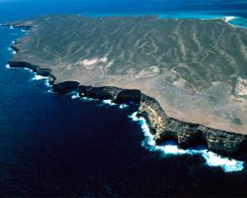

*8. Activity: Draw/illustrate/make up either of the following using icons of the area, and/or images of the town/area which give the place it’s local flavour/identity:*

A. Currency B. Flag C. A new icon D. A poster E. Your own idea



C:\Users\Chris\AppData\Local\Microsoft\Windows\Temporary Internet Files\Content.IE5\H9WM8K7A\MCj03561130000[1].wmf

*A SOSE/English/Mathematics Unit*

1. Name of the Town/Place? ____________________________
2. Name of the Province/Area? __________________________
3. What State is it in? ________________________________
4. Closest Major City to the place?________________________
5. Special Features of the town/area? _____________________

___________________________________________________

1. Name of the next nearest town or city N-S-E-W of the place:

North South East West

____________ ____________ ____________ _____________

1. Library/Research Skills. Where in the library would you find literature if you wanted to find more out about the item in the picture, and/or the area? Think about the Dewey and other systems.

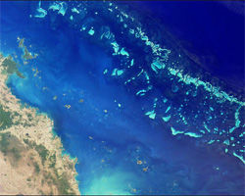

*8. Activity: Draw/illustrate/make up either of the following using icons of the area, and/or images of the town/area which give the place it’s local flavour/identity:*

A. Currency B. Flag C. A new icon D. A poster E. Your own idea



C:\Users\Chris\AppData\Local\Microsoft\Windows\Temporary Internet Files\Content.IE5\H9WM8K7A\MCj03561130000[1].wmf

*A SOSE/English/Mathematics Unit*

1. Name of the Town/Place? ____________________________
2. Name of the Province/Area? __________________________
3. What State is it in? ________________________________
4. Closest Major City to the place?________________________
5. Special Features of the town/area? _____________________

___________________________________________________

1. Name of the next nearest town or city N-S-E-W of the place:

North South East West

____________ ____________ ____________ _____________

1. Library/Research Skills. Where in the library would you find literature if you wanted to find more out about the item in the picture, and/or the area? Think about the Dewey and other systems.

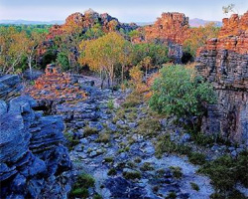

*8. Activity: Draw/illustrate/make up either of the following using icons of the area, and/or images of the town/area which give the place it’s local flavour/identity:*

A. Currency B. Flag C. A new icon D. A poster E. Your own idea



C:\Users\Chris\AppData\Local\Microsoft\Windows\Temporary Internet Files\Content.IE5\H9WM8K7A\MCj03561130000[1].wmf

*A SOSE/English/Mathematics Unit*

1. Name of the Town/Place? ____________________________
2. Name of the Province/Area? __________________________
3. What State is it in? ________________________________
4. Closest Major City to the place?________________________
5. Special Features of the town/area? _____________________

___________________________________________________

1. Name of the next nearest town or city N-S-E-W of the place:

North South East West

____________ ____________ ____________ _____________

1. Library/Research Skills. Where in the library would you find literature if you wanted to find more out about the item in the picture, and/or the area? Think about the Dewey and other systems.

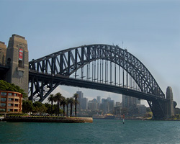

*8. Activity: Draw/illustrate/make up either of the following using icons of the area, and/or images of the town/area which give the place it’s local flavour/identity:*

A. Currency B. Flag C. A new icon D. A poster E. Your own idea



C:\Users\Chris\AppData\Local\Microsoft\Windows\Temporary Internet Files\Content.IE5\H9WM8K7A\MCj03561130000[1].wmf

*A SOSE/English/Mathematics Unit*

1. Name of the Town/Place? ____________________________
2. Name of the Province/Area? __________________________
3. What State is it in? ________________________________
4. Closest Major City to the place?________________________
5. Special Features of the town/area? _____________________

___________________________________________________

1. Name of the next nearest town or city N-S-E-W of the place:

North South East West

____________ ____________ ____________ _____________

1. Library/Research Skills. Where in the library would you find literature if you wanted to find more out about the item in the picture, and/or the area? Think about the Dewey and other systems.

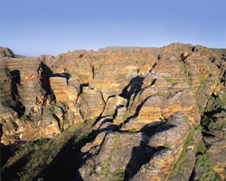

*8. Activity: Draw/illustrate/make up either of the following using icons of the area, and/or images of the town/area which give the place it’s local flavour/identity:*

A. Currency B. Flag C. A new icon D. A poster E. Your own idea



C:\Users\Chris\AppData\Local\Microsoft\Windows\Temporary Internet Files\Content.IE5\H9WM8K7A\MCj03561130000[1].wmf

*A SOSE/English/Mathematics Unit*

1. Name of the Town/Place? ____________________________
2. Name of the Province/Area? __________________________
3. What State is it in? ________________________________
4. Closest Major City to the place?________________________
5. Special Features of the town/area? _____________________

___________________________________________________

1. Name of the next nearest town or city N-S-E-W of the place:

North South East West

____________ ____________ ____________ _____________

1. Library/Research Skills. Where in the library would you find literature if you wanted to find more out about the item in the picture, and/or the area? Think about the Dewey and other systems.

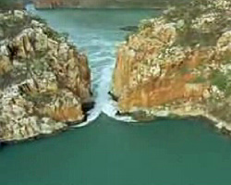

*8. Activity: Draw/illustrate/make up either of the following using icons of the area, and/or images of the town/area which give the place it’s local flavour/identity:*

A. Currency B. Flag C. A new icon D. A poster E. Your own idea



C:\Users\Chris\AppData\Local\Microsoft\Windows\Temporary Internet Files\Content.IE5\H9WM8K7A\MCj03561130000[1].wmf

*A SOSE/English/Mathematics Unit*

1. Name of the Town/Place? ____________________________
2. Name of the Province/Area? __________________________
3. What State is it in? ________________________________
4. Closest Major City to the place?________________________
5. Special Features of the town/area? _____________________

___________________________________________________

1. Name of the next nearest town or city N-S-E-W of the place:

North South East West

____________ ____________ ____________ _____________

1. Library/Research Skills. Where in the library would you find literature if you wanted to find more out about the item in the picture, and/or the area? Think about the Dewey and other systems.

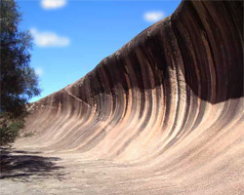

*8. Activity: Draw/illustrate/make up either of the following using icons of the area, and/or images of the town/area which give the place it’s local flavour/identity:*

A. Currency B. Flag C. A new icon D. A poster E. Your own idea



C:\Users\Chris\AppData\Local\Microsoft\Windows\Temporary Internet Files\Content.IE5\H9WM8K7A\MCj03561130000[1].wmf

*A SOSE/English/Mathematics Unit*

1. Name of the Town/Place? ____________________________
2. Name of the Province/Area? __________________________
3. What State is it in? ________________________________
4. Closest Major City to the place?________________________
5. Special Features of the town/area? _____________________

___________________________________________________

1. Name of the next nearest town or city N-S-E-W of the place:

North South East West

____________ ____________ ____________ _____________

1. Library/Research Skills. Where in the library would you find literature if you wanted to find more out about the item in the picture, and/or the area? Think about the Dewey and other systems.

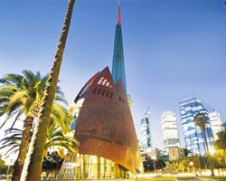

*8. Activity: Draw/illustrate/make up either of the following using icons of the area, and/or images of the town/area which give the place it’s local flavour/identity:*

A. Currency B. Flag C. A new icon D. A poster E. Your own idea



C:\Users\Chris\AppData\Local\Microsoft\Windows\Temporary Internet Files\Content.IE5\H9WM8K7A\MCj03561130000[1].wmf

*A SOSE/English/Mathematics Unit*

1. Name of the Town/Place? ____________________________
2. Name of the Province/Area? __________________________
3. What State is it in? ________________________________
4. Closest Major City to the place?________________________
5. Special Features of the town/area? _____________________

___________________________________________________

1. Name of the next nearest town or city N-S-E-W of the place:

North South East West

____________ ____________ ____________ _____________

1. Library/Research Skills. Where in the library would you find literature if you wanted to find more out about the item in the picture, and/or the area? Think about the Dewey and other systems.

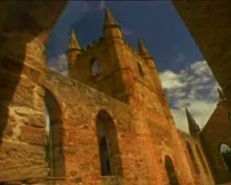

*8. Activity: Draw/illustrate/make up either of the following using icons of the area, and/or images of the town/area which give the place it’s local flavour/identity:*

A. Currency B. Flag C. A new icon D. A poster E. Your own idea



C:\Users\Chris\AppData\Local\Microsoft\Windows\Temporary Internet Files\Content.IE5\H9WM8K7A\MCj03561130000[1].wmf

*A SOSE/English/Mathematics Unit*

1. Name of the Town/Place? ____________________________
2. Name of the Province/Area? __________________________
3. What State is it in? ________________________________
4. Closest Major City to the place?________________________
5. Special Features of the town/area? _____________________

___________________________________________________

1. Name of the next nearest town or city N-S-E-W of the place:

North South East West

____________ ____________ ____________ _____________

1. Library/Research Skills. Where in the library would you find literature if you wanted to find more out about the item in the picture, and/or the area? Think about the Dewey and other systems.

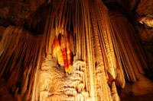

*8. Activity: Draw/illustrate/make up either of the following using icons of the area, and/or images of the town/area which give the place it’s local flavour/identity:*

A. Currency B. Flag C. A new icon D. A poster E. Your own idea



C:\Users\Chris\AppData\Local\Microsoft\Windows\Temporary Internet Files\Content.IE5\H9WM8K7A\MCj03561130000[1].wmf

*A SOSE/English/Mathematics Unit*

1. Name of the Town/Place? ____________________________
2. Name of the Province/Area? __________________________
3. What State is it in? ________________________________
4. Closest Major City to the place?________________________
5. Special Features of the town/area? _____________________

___________________________________________________

1. Name of the next nearest town or city N-S-E-W of the place:

North South East West

____________ ____________ ____________ _____________

1. Library/Research Skills. Where in the library would you find literature if you wanted to find more out about the item in the picture, and/or the area? Think about the Dewey and other systems.

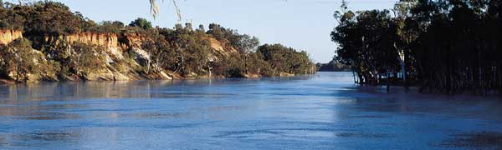

*8. Activity: Draw/illustrate/make up either of the following using icons of the area, and/or images of the town/area which give the place it’s local flavour/identity:*

A. Currency B. Flag C. A new icon D. A poster E. Your own idea



C:\Users\Chris\AppData\Local\Microsoft\Windows\Temporary Internet Files\Content.IE5\H9WM8K7A\MCj03561130000[1].wmf

*A SOSE/English/Mathematics Unit*

1. Name of the Town/Place? ____________________________
2. Name of the Province/Area? __________________________
3. What State is it in? ________________________________
4. Closest Major City to the place?________________________
5. Special Features of the town/area? _____________________

___________________________________________________

1. Name of the next nearest town or city N-S-E-W of the place:

North South East West

____________ ____________ ____________ _____________

1. Library/Research Skills. Where in the library would you find literature if you wanted to find more out about the item in the picture, and/or the area? Think about the Dewey and other systems.

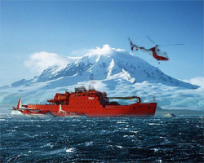

*8. Activity: Draw/illustrate/make up either of the following using icons of the area, and/or images of the town/area which give the place it’s local flavour/identity:*

A. Currency B. Flag C. A new icon D. A poster E. Your own idea



C:\Users\Chris\AppData\Local\Microsoft\Windows\Temporary Internet Files\Content.IE5\H9WM8K7A\MCj03561130000[1].wmf

*A SOSE/English/Mathematics Unit*

1. Name of the Town/Place? ____________________________
2. Name of the Province/Area? __________________________
3. What State is it in? ________________________________
4. Closest Major City to the place?________________________
5. Special Features of the town/area? _____________________

___________________________________________________

1. Name of the next nearest town or city N-S-E-W of the place:

North South East West

____________ ____________ ____________ _____________

1. Library/Research Skills. Where in the library would you find literature if you wanted to find more out about the item in the picture, and/or the area? Think about the Dewey and other systems.

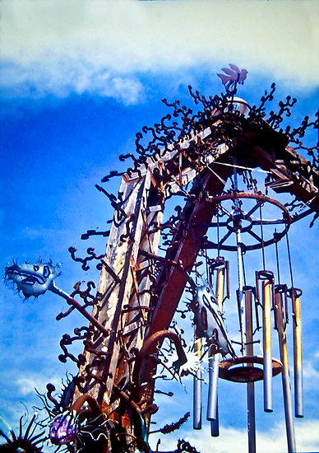

*8. Activity: Draw/illustrate/make up either of the following using icons of the area, and/or images of the town/area which give the place it’s local flavour/identity:*

A. Currency B. Flag C. A new icon D. A poster E. Your own idea



C:\Users\Chris\AppData\Local\Microsoft\Windows\Temporary Internet Files\Content.IE5\H9WM8K7A\MCj03561130000[1].wmf

*A SOSE/English/Mathematics Unit*

1. Name of the Town/Place? ____________________________
2. Name of the Province/Area? __________________________
3. What State is it in? ________________________________
4. Closest Major City to the place?________________________
5. Special Features of the town/area? _____________________

___________________________________________________

1. Name of the next nearest town or city N-S-E-W of the place:

North South East West

____________ ____________ ____________ _____________

1. Library/Research Skills. Where in the library would you find literature if you wanted to find more out about the item in the picture, and/or the area? Think about the Dewey and other systems.

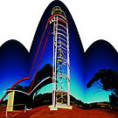

*8. Activity: Draw/illustrate/make up either of the following using icons of the area, and/or images of the town/area which give the place it’s local flavour/identity:*

A. Currency B. Flag C. A new icon D. A poster E. Your own idea



C:\Users\Chris\AppData\Local\Microsoft\Windows\Temporary Internet Files\Content.IE5\H9WM8K7A\MCj03561130000[1].wmf

*A SOSE/English/Mathematics Unit*

1. Name of the Town/Place? ____________________________
2. Name of the Province/Area? __________________________
3. What State is it in? ________________________________
4. Closest Major City to the place?________________________
5. Special Features of the town/area? _____________________

___________________________________________________

1. Name of the next nearest town or city N-S-E-W of the place:

North South East West

____________ ____________ ____________ _____________

1. Library/Research Skills. Where in the library would you find literature if you wanted to find more out about the item in the picture, and/or the area? Think about the Dewey and other systems.

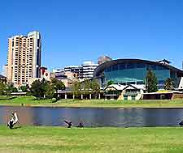

*8. Activity: Draw/illustrate/make up either of the following using icons of the area, and/or images of the town/area which give the place it’s local flavour/identity:*

A. Currency B. Flag C. A new icon D. A poster E. Your own idea



C:\Users\Chris\AppData\Local\Microsoft\Windows\Temporary Internet Files\Content.IE5\H9WM8K7A\MCj03561130000[1].wmf

*A SOSE/English/Mathematics Unit*

1. Name of the Town/Place? ____________________________
2. Name of the Province/Area? __________________________
3. What State is it in? ________________________________
4. Closest Major City to the place?________________________
5. Special Features of the town/area? _____________________

___________________________________________________

1. Name of the next nearest town or city N-S-E-W of the place:

North South East West

____________ ____________ ____________ _____________

1. Library/Research Skills. Where in the library would you find literature if you wanted to find more out about the item in the picture, and/or the area? Think about the Dewey and other systems.

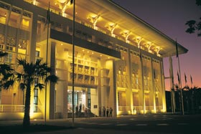

*8. Activity: Draw/illustrate/make up either of the following using icons of the area, and/or images of the town/area which give the place it’s local flavour/identity:*

A. Currency B. Flag C. A new icon D. A poster E. Your own idea



C:\Users\Chris\AppData\Local\Microsoft\Windows\Temporary Internet Files\Content.IE5\H9WM8K7A\MCj03561130000[1].wmf

*A SOSE/English/Mathematics Unit*

1. Name of the Town/Place? ____________________________
2. Name of the Province/Area? __________________________
3. What State is it in? ________________________________
4. Closest Major City to the place?________________________
5. Special Features of the town/area? _____________________

___________________________________________________

1. Name of the next nearest town or city N-S-E-W of the place:

North South East West

____________ ____________ ____________ _____________

1. Library/Research Skills. Where in the library would you find literature if you wanted to find more out about the item in the picture, and/or the area? Think about the Dewey and other systems.

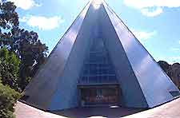

*8. Activity: Draw/illustrate/make up either of the following using icons of the area, and/or images of the town/area which give the place it’s local flavour/identity:*

A. Currency B. Flag C. A new icon D. A poster E. Your own idea



C:\Users\Chris\AppData\Local\Microsoft\Windows\Temporary Internet Files\Content.IE5\H9WM8K7A\MCj03561130000[1].wmf

*A SOSE/English/Mathematics Unit*

1. Name of the Town/Place? ____________________________
2. Name of the Province/Area? __________________________
3. What State is it in? ________________________________
4. Closest Major City to the place?________________________
5. Special Features of the town/area? _____________________

___________________________________________________

1. Name of the next nearest town or city N-S-E-W of the place:

North South East West

____________ ____________ ____________ _____________

1. Library/Research Skills. Where in the library would you find literature if you wanted to find more out about the item in the picture, and/or the area? Think about the Dewey and other systems.

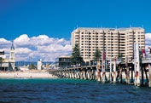

*8. Activity: Draw/illustrate/make up either of the following using icons of the area, and/or images of the town/area which give the place it’s local flavour/identity:*

A. Currency B. Flag C. A new icon D. A poster E. Your own idea



C:\Users\Chris\AppData\Local\Microsoft\Windows\Temporary Internet Files\Content.IE5\H9WM8K7A\MCj03561130000[1].wmf

*A SOSE/English/Mathematics Unit*

1. Name of the Town/Place? ____________________________
2. Name of the Province/Area? __________________________
3. What State is it in? ________________________________
4. Closest Major City to the place?________________________
5. Special Features of the town/area? _____________________

___________________________________________________

1. Name of the next nearest town or city N-S-E-W of the place:

North South East West

____________ ____________ ____________ _____________

1. Library/Research Skills. Where in the library would you find literature if you wanted to find more out about the item in the picture, and/or the area? Think about the Dewey and other systems.

*8. Activity: Draw/illustrate/make up either of the following using icons of the area, and/or images of the town/area which give the place it’s local flavour/identity:*

A. Currency B. Flag C. A new icon D. A poster E. Your own idea



C:\Users\Chris\AppData\Local\Microsoft\Windows\Temporary Internet Files\Content.IE5\H9WM8K7A\MCj03561130000[1].wmf

*A SOSE/English/Mathematics Unit*

|  |  |  |
| --- | --- | --- |
| Card Number | Name of Place (Icon) | State |
| 1 | Sydney Opera House | NSW |
| 2 | Ayres Rock / Uluru | NT |
| 3 | Shark Bay | WA |
| 4 | Great Barrier Reef | QLD |
| 5 | Kakadu National Park | NT |
| 6 | Sydney Harbour Bridge | NSW |
| 7 | Bungle Bungles | WA |
| 8 | Horizontal Falls Near Talbot Bay | WA |
| 9 | Wave Rock near Hyden | WA |
| 10 | Swan Bells (Perth) | WA |
| 11 | Port Arthur | Tasmania |
| 12 | Jenola Caves in the Blue Mountains | NSW |
| 13 | Part of the Murray River | Victoria |
| 14 | Australian Antarctic Territory | Not in a State but Ozzie property |
| 15 | Wellington Gateway | NSW |
| 16 | Mining Tower | WA |
| 17 | Adelaide Convention Centre/Torrens River | SA |
| 18 | Darwin Parliament House | NT |
| 19 | Bicentennial Conservatory in Adelaide | SA |
| 20 | Glenlg | SA |
| 21 | Children make up their own | N/A |