MCj03981290000[1]MCj04238280000[1]

*Answer the following questions:*

1. **What is my name?**
2. **Why am I famous / well known?**
3. **What is the name of the place I work in?**
4. **What city do I work in?**
5. **What is my home town / city?**
6. **List 5 other things about me. Try and make these points things that are related to either me or my work.**
7. **Extra: Make up a mini biography about me. Include illustrations/sketches of either me or things related to me.**

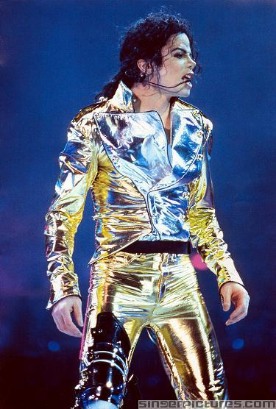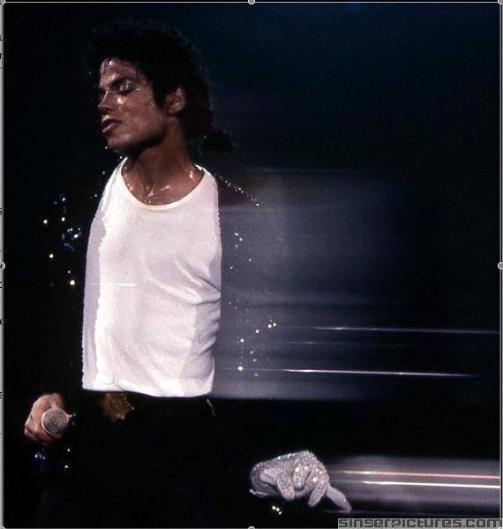

*C. Stevenson/Kiwi Resources* [*kiwiresources@vodafone.net.nz*](mailto:kiwiresources@vodafone.net.nz)

MCj03981290000[1]MCj04238280000[1]

*Answer the following questions:*

1. **What is my name?**
2. **Why was I famous / well known?**
3. **What is the name of the place I work in?**
4. **What city do I work in?**
5. **What is my home town / city?**
6. **List 5 other things about me. Try and make these points things that are related to either me or my work.**
7. **Extra: Make up a mini biography about me. Include illustrations/sketches of either me or things related to me.**

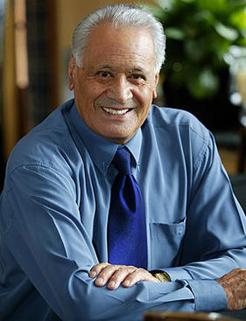

*C. Stevenson/Kiwi Resources* [*kiwiresources@vodafone.net.nz*](mailto:kiwiresources@vodafone.net.nz)

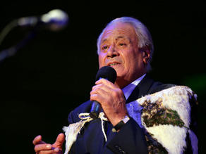

MCj03981290000[1]MCj04238280000[1]

*Answer the following questions:*

1. **What is my name?**
2. **Why am I famous / well known?**
3. **What is the name of the place I work in?**
4. **What city do I work in?**
5. **What is my home town / city?**
6. **List 5 other things about me. Try and make these points things that are related to either me or my work.**
7. **Extra: Make up a mini biography about me. Include illustrations/sketches of either me or things related to me.**

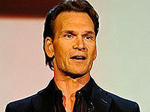

*C. Stevenson/Kiwi Resources* [*kiwiresources@vodafone.net.nz*](mailto:kiwiresources@vodafone.net.nz)



MCj03981290000[1]MCj04238280000[1]

*Answer the following questions:*

1. **What is my name?**
2. **Why am I famous / well known?**
3. **What is the name of the place I work in?**
4. **What city do I work in?**
5. **What is my home town / city?**
6. **List 5 other things about me. Try and make these points things that are related to either me or my work.**
7. **Extra: Make up a mini biography about me. Include illustrations/sketches of either me or things related to me.**

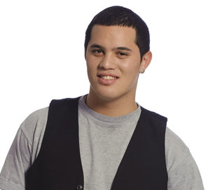

*C. Stevenson/Kiwi Resources* [*kiwiresources@vodafone.net.nz*](mailto:kiwiresources@vodafone.net.nz)

MCj03981290000[1]MCj04238280000[1]

*Answer the following questions:*

1. **What is my name?**
2. **Why am I famous / well known?**
3. **What is the name of the place I work in?**
4. **What city do I work in?**
5. **What is my home town / city?**
6. **List 5 other things about me. Try and make these points things that are related to either me or my work.**
7. **Extra: Make up a mini biography about me. Include illustrations/sketches of either me or things related to me.**

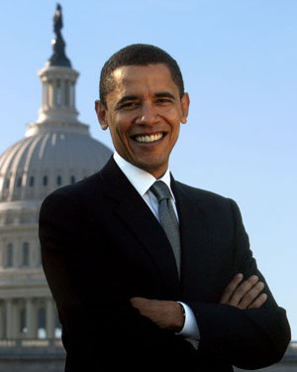

*C. Stevenson/Kiwi Resources* [*kiwiresources@vodafone.net.nz*](mailto:kiwiresources@vodafone.net.nz)

MCj03981290000[1]MCj04238280000[1]

*Answer the following questions:*

1. **What is my name?**
2. **Why am I famous / well known?**
3. **What is the name of the place I work in?**
4. **What city do I work in?**
5. **What is my home town / city?**
6. **List 5 other things about me. Try and make these points things that are related to either me or my work.**
7. **Extra: Make up a mini biography about me. Include illustrations/sketches of either me or things related to me.**

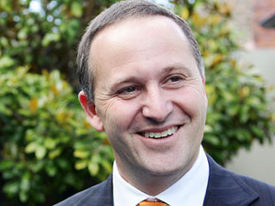

*C. Stevenson/Kiwi Resources* [*kiwiresources@vodafone.net.nz*](mailto:kiwiresources@vodafone.net.nz)

MCj03981290000[1]MCj04238280000[1]

*Answer the following questions:*

1. **What is my name?**
2. **Why am I famous / well known?**
3. **What is the name of the place I work in?**
4. **What city do I work in?**
5. **What is my home town / city?**
6. **List 5 other things about me. Try and make these points things that are related to either me or my work.**
7. **Extra: Make up a mini biography about me. Include illustrations/sketches of either me or things related to me.**

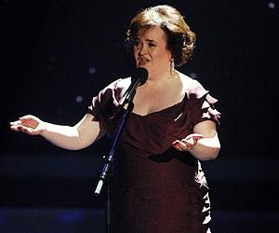

*C. Stevenson/Kiwi Resources* [*kiwiresources@vodafone.net.nz*](mailto:kiwiresources@vodafone.net.nz)

MCj03981290000[1]MCj04238280000[1]

*Answer the following questions:*

1. **What is my name?**
2. **Why am I famous / well known?**
3. **What is the name of the place I work in?**
4. **What city do I work in?**
5. **What is my home town / city?**
6. **List 5 other things about me. Try and make these points things that are related to either me or my work.**
7. **Extra: Make up a mini biography about me. Include illustrations/sketches of either me or things related to me.**

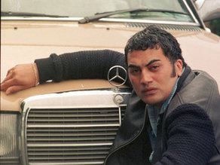

*C. Stevenson/Kiwi Resources* [*kiwiresources@vodafone.net.nz*](mailto:kiwiresources@vodafone.net.nz)

MCj03981290000[1]MCj04238280000[1]

*Answer the following questions:*

1. **What is my name?**
2. **Why am I famous / well known?**
3. **What is the name of the place I work in?**
4. **What city do I work in?**
5. **What is my home town / city?**
6. **List 5 other things about me. Try and make these points things that are related to either me or my work.**
7. **Extra: Make up a mini biography about me. Include illustrations/sketches of either me or things related to me.**

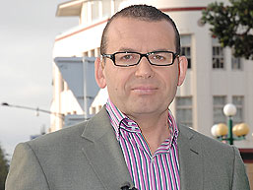

*C. Stevenson/Kiwi Resources* [*kiwiresources@vodafone.net.nz*](mailto:kiwiresources@vodafone.net.nz)

MCj03981290000[1]MCj04238280000[1]

*Answer the following questions:*

1. **What is my name?**
2. **Why am I famous / well known?**
3. **What is the name of the place I work in?**
4. **What city do I work in?**
5. **What is my home town / city?**
6. **List 5 other things about me. Try and make these points things that are related to either me or my work.**
7. **Extra: Make up a mini biography about me. Include illustrations/sketches of either me or things related to me.**

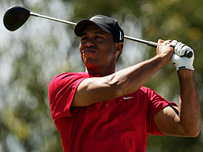

*C. Stevenson/Kiwi Resources* [*kiwiresources@vodafone.net.nz*](mailto:kiwiresources@vodafone.net.nz)

MCj03981290000[1]MCj04238280000[1]

*Answer the following questions:*

1. **What is my name?**
2. **Why am I famous / well known?**
3. **What is the name of the place I work in?**
4. **What city do I work in?**
5. **What is my home town / city?**
6. **List 5 other things about me. Try and make these points things that are related to either me or my work.**
7. **Extra: Make up a mini biography about me. Include illustrations/sketches of either me or things related to me.**

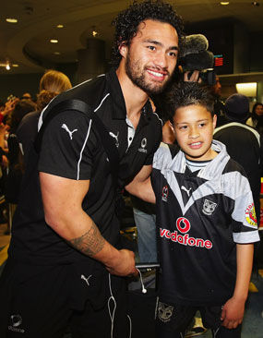

*C. Stevenson/Kiwi Resources* [*kiwiresources@vodafone.net.nz*](mailto:kiwiresources@vodafone.net.nz)

MCj03981290000[1]MCj04238280000[1]

*Answer the following questions:*

1. **What is my name?**
2. **Why am I famous / well known?**
3. **What is the name of the place I work in?**
4. **What city do I work in?**
5. **What is my home town / city?**
6. **List 5 other things about me. Try and make these points things that are related to either me or my work.**
7. **Extra: Make up a mini biography about me. Include illustrations/sketches of either me or things related to me.**

*C. Stevenson/Kiwi Resources* [*kiwiresources@vodafone.net.nz*](mailto:kiwiresources@vodafone.net.nz)

